**Chapter 1: Planning**

**Description :**

kidz newz network cheesy cheeze burger is a shop that sells in-trend shoes and sneakers to the public.

**Reason :**

The website is to create an online platform to sell shoes to the public and make more profit out of the business.

**Objectives :**

To provide a detailed and easy-to-understand platform for the customers that visits the website.

**Potential Users :**

Teenagers, Adults

**Information the users need and want :**

An account to purchase shoes, prices of shoes, promotion events, shoe showcases, location of shop, contact details.

|  |  |
| --- | --- |
| **Needs** | **Wants** |
| Price of single item | Discounts |
| Locations | Introduction of company |
| Product details | Contact number |
| Price of item selected | Member signing up |
| Sizing guides | Simple payment methods |
| Low delivery fee | Benefits of member |

**Proposed deliverable of the final web site (include all the activities and duration involved)**

|  |  |
| --- | --- |
| **Week** | **Task** |
| **1** | **Planning** |
| **2** | **Finalising chapter 1** |
| **3** | **Sketching web pages** |
| **4** | **Work on html** |
| **5** | **Work on CSS and Java Script** |
| **6** | **Combination and checking** |
| **7** | **Presentation and Submission** |

**Chapter 2: Web Analysis**

**Pages**

* aboutus.html
* help.html
* homepage.html
* sizeguide.html
* shoes1.html
* female.html
* login.html
* payment.html
* airforce.html
* feedbackform.html
* mens.html
* registerform.html
* shoppingcart.html
* product.html
* comingsoon.html
* event.html
* Contactus.html
* Forgetpass.html
* profile.html

**Header**

* List to choose languages
* Logo linked to Home page
* Button linked to Login page and register page
* Button to play music
* Buttons to toggle volume
* Hover to show cart with buttons linked to shopping cart and feedback form
* List with links to Home, Men, Women, Coming Soon, Contact Us, Event and Help pages

**product.html**

* Breadcrumbs to previous pages
* Modal Image
* Carousel
* Buttons to choose country of shoe sizes
* Buttons to choose shoe sizes according to the country chosen
* Link to Size Guide
* Amount selector
* Add-to-cart button
* Tabs to switch around Description, Specifications, Reviews
* Lightbox Gallery
* Table for specifications
* Hover-able and choose-able stars
* Form for comments with form check
* Links to Men / Women pages
* Checkbox for brands
* Slider for price range
* Checkbox for colors
* Button for filter
* Selectable size buttons
* Tags that links to Men / Women pages

**comingsoon.html**

* Breadcrumbs to previous pages
* Search bar
* Buttons to filter shoe categories
* Button to filter shoe brands
* Links to latest additions (Nike Air Force 1 Low links to product.html)
* Tags that links to Men / Women pages
* Collapsible
* Countdown timer

**contactus.html**

* Breadcrumbs to previous pages
* Embedded Google Map
* Forms for comments with form check
* Button to submit comments

**event.html**

* Images that can be linked to their respective content
* Snowing effect
* Smooth scrolling
* Countdown timer
* Hover to show details box
* Link to home
* Label that links to the items area
* Hover over image to show item information
* Tilting animation images
* Back to top of page label

**Airforce.html**

* Header function as stated as above
* Previous button
* Add to cart button
* Automated slideshow

**Feedbackform.html**

* Six radio button for customer to select
* Suggestion box
* Email box
* Submit button with alert

**Mens.html**

* View all product for mens
* Button to to redirect straight to the product

**Registerform.html**

* Spaces for customer to enter all their details
* Required functions
* Fill up blank field notification
* Submit button alert
* Email validation (must require @)

**Shoppingcart.html**

* Add / Minus button function to add or decrease product
* Auto calculate single item price
* Size button
* Auto calculated total price with taxes and shipping fee
* Checkout button
* No limit of product can be purchased

**homepage.html**

* link to other pages
* Slideshow of shoes
* Some shoes of men
* Featured shoes

**aboutus.html**

* List of workers
* The purpose of the company
* Youtube videos to show
* Link to home
* Show the quick links
* Show telephone number

**help.html**

* Show quick assists
* Show the question that customer will ask
* Table for specifications
* Link to Size Guide pages
* Tags that link to answer pages

**sizeguide.html**

* To let the customer know the size
* Table for specifications
* Link to homepage

**Female.html**

* View all product for womens
* Link to view details of shoes1

**Shoes1.html**

* Button to add to chart
* Link to female.html
* View product of shoes1, details and design
* Slideshow of shoes1

**Profile.html**

* Link to add to chart
* Link to homepage
* Edit profile

**Payment.html**

* Address box
* Name box
* Detail of credit card box

**Login.html**

* Username box
* Password box
* Click to remember members’ account
* Link to homepage
* Link to register

**Forgetpass.html**

* Username box
* Email box
* Button to requires serial number
* Serial number box
* Link to profile.html

**Organization of the Website**

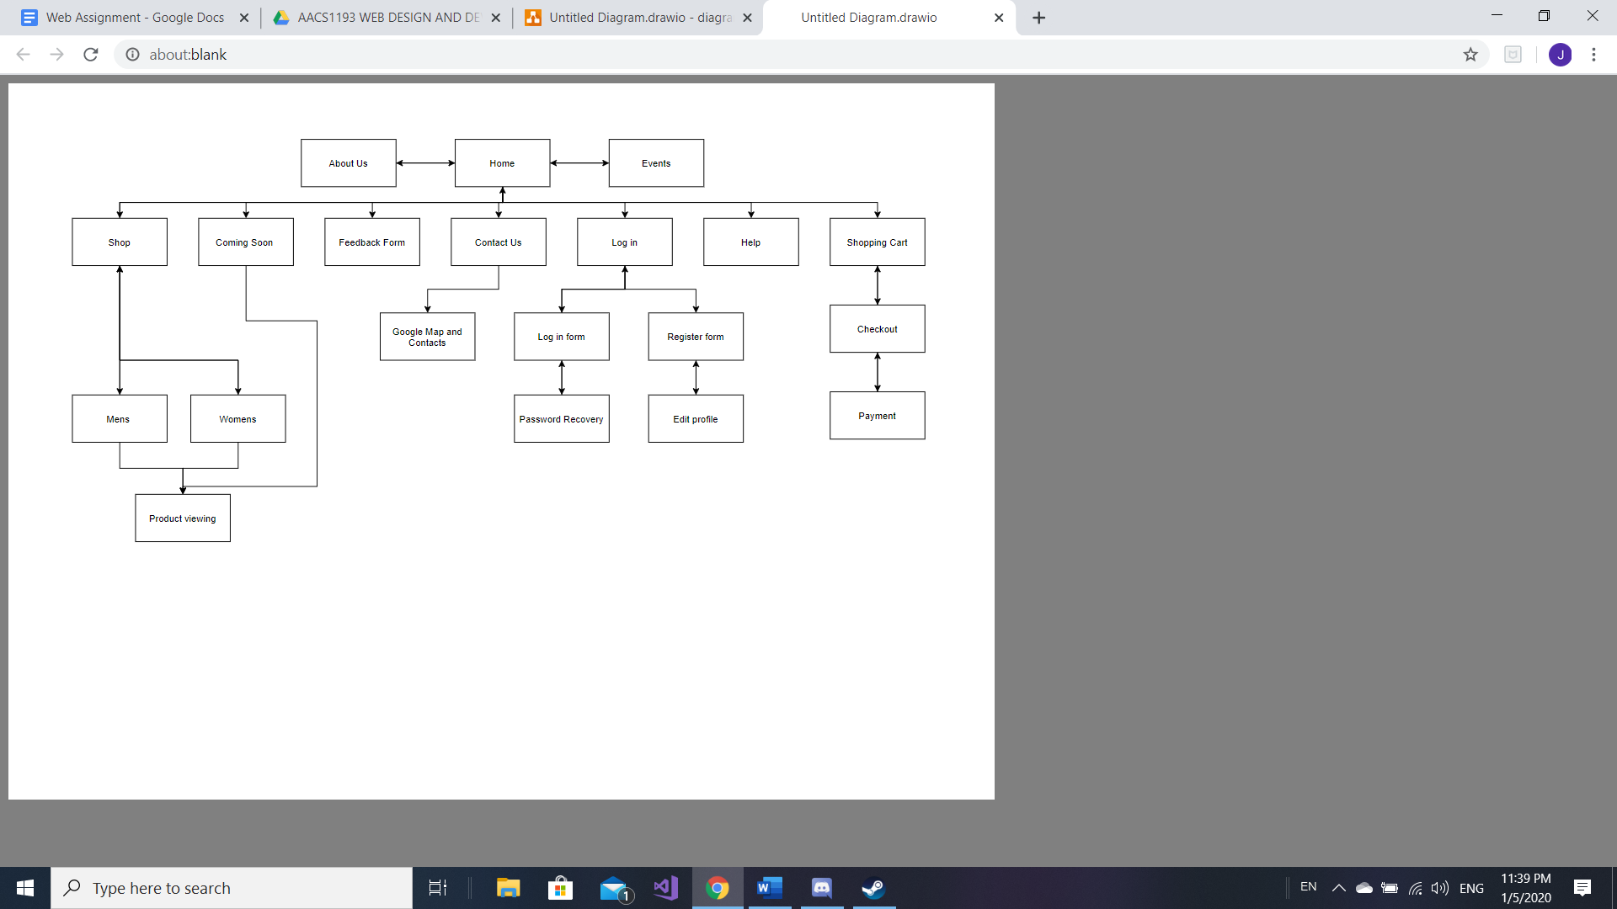

**Chapter 3: Web Design**

**Web Design Sketching and Elaboration**

|  |
| --- |
| header  product.html  comingsoon.html  contactus.html  event.html  aboutus.html  help.html  homepage.html  sizeguide.html  shoes1.html  female.html  login.html  payment.html  airforce.html  feedbackform.html  mens.html  registerform.html  shoppingcart.html |

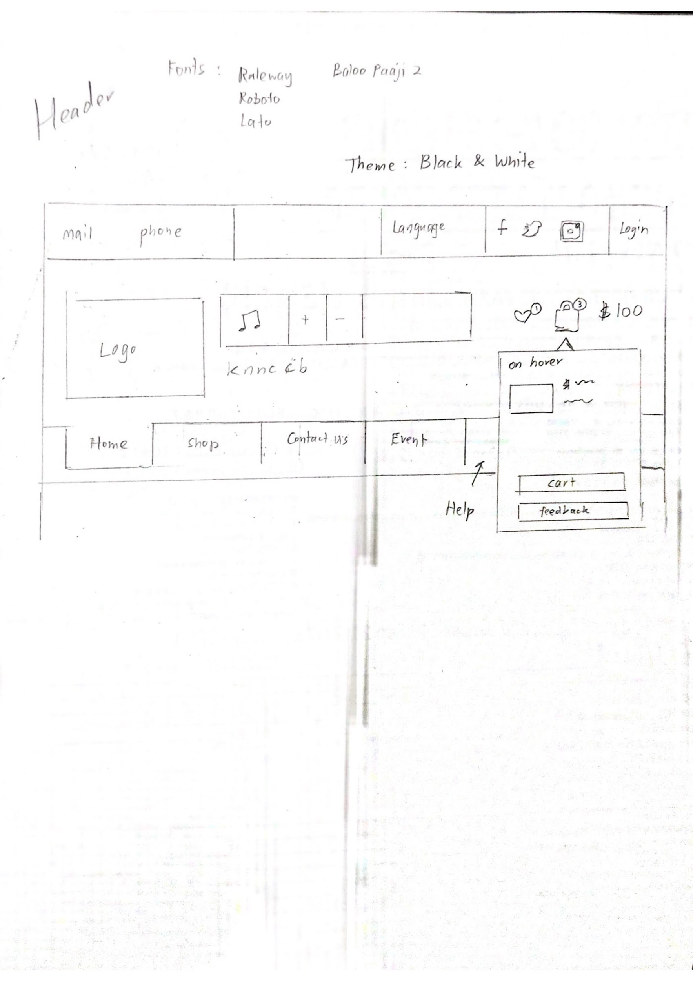

**Header**

The overall color theme of the website is a black and white combination. The header has multiple functions, this includes buttons to play music and toggling the volume, multiple icons that link to social media and login page, a language choosing selector. A hover-able cart to show items in the cart which also contains button links to the shopping cart and feedback form. And a list of buttons that link to different pages.

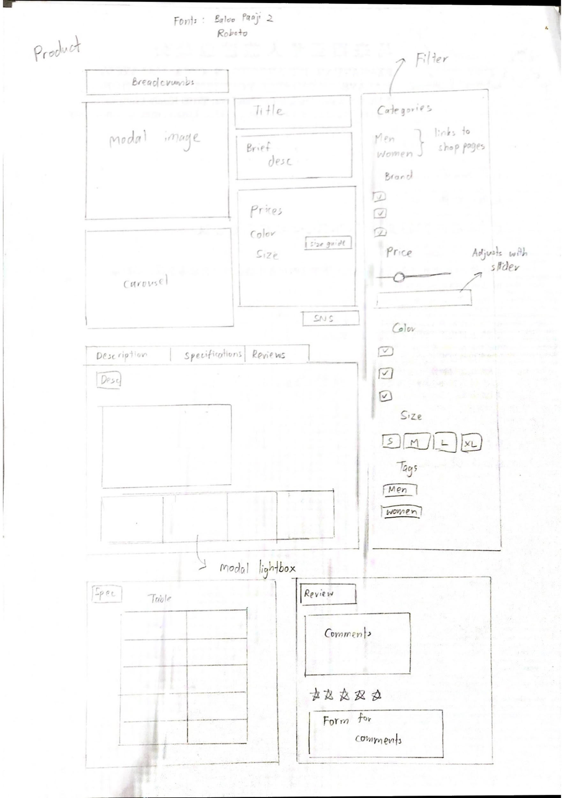

**Product Page**

Includes breadcrumbs section to previous pages on the top.

For the product details section, there’s an image of the product that can be zoomed on click on the top. A carousel module that shows different images of the product at different angles. There are also buttons to choose the country and its respective shoe sizes. There would be a link to the shoe size guide and an amount selector for the shoe being sold. Once everything is settled, you can add the items to your cart by clicking on the add-to-cart button.

For the tabs section, there are 3 tabs, description tab, specification tab and reviews tab. Within the description tab shows the introduction to the shoe and a lightbox with pictures of different colors of the product. Within the specification tab shows the specifications of the product. Within the reviews tab shows comments made by other users, a rating box and a form to leave comments.

For the filtering section, there are links to the main pages for shoes, checkboxes for brands, sizes and colors. It also includes a slider to adjust the price range to the desired price range of the items. And tags on the bottom to link back to the main pages.

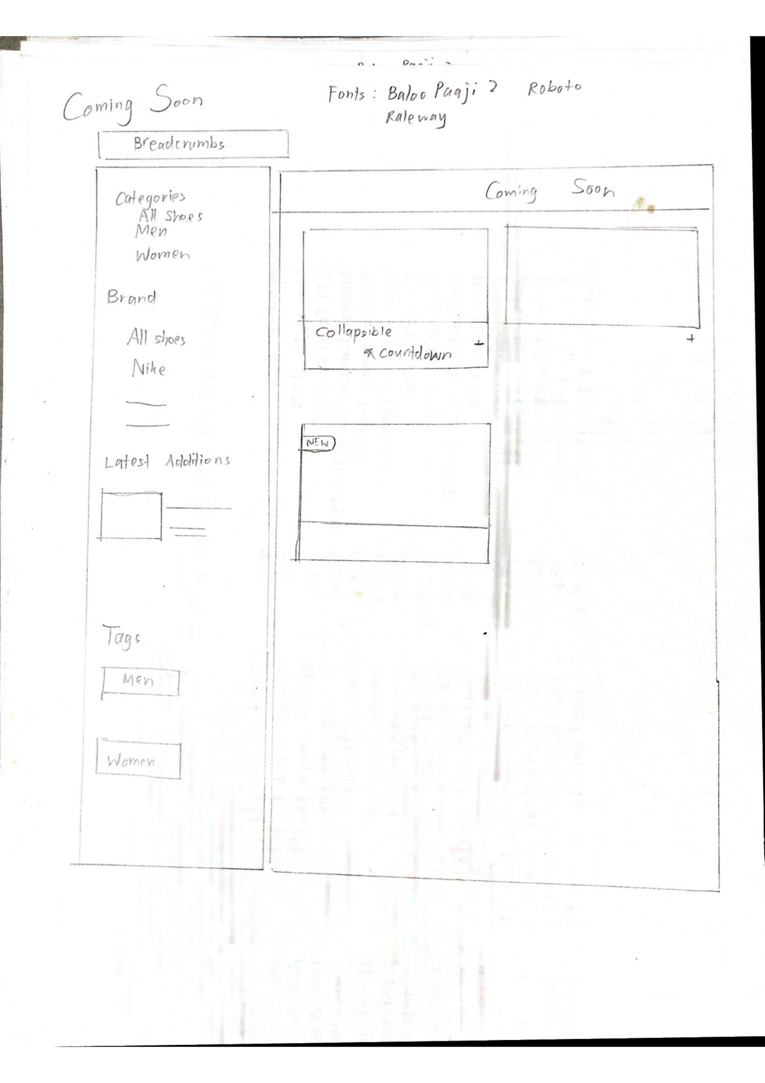

**Coming Soon Page**

The coming soon page includes breadcrumbs to previous pages on the top.

On the left, there is a filter bar. Within the filter bar includes a search bar, buttons to filter shoe categories and brands within the page, links to the latest additions and tags that links to the main shop pages.

On the right, there are collapsibles that can be clicked on to show the status of the shoes with a countdown timer, and for shoes that are already released, it will show the words “RELEASED”.

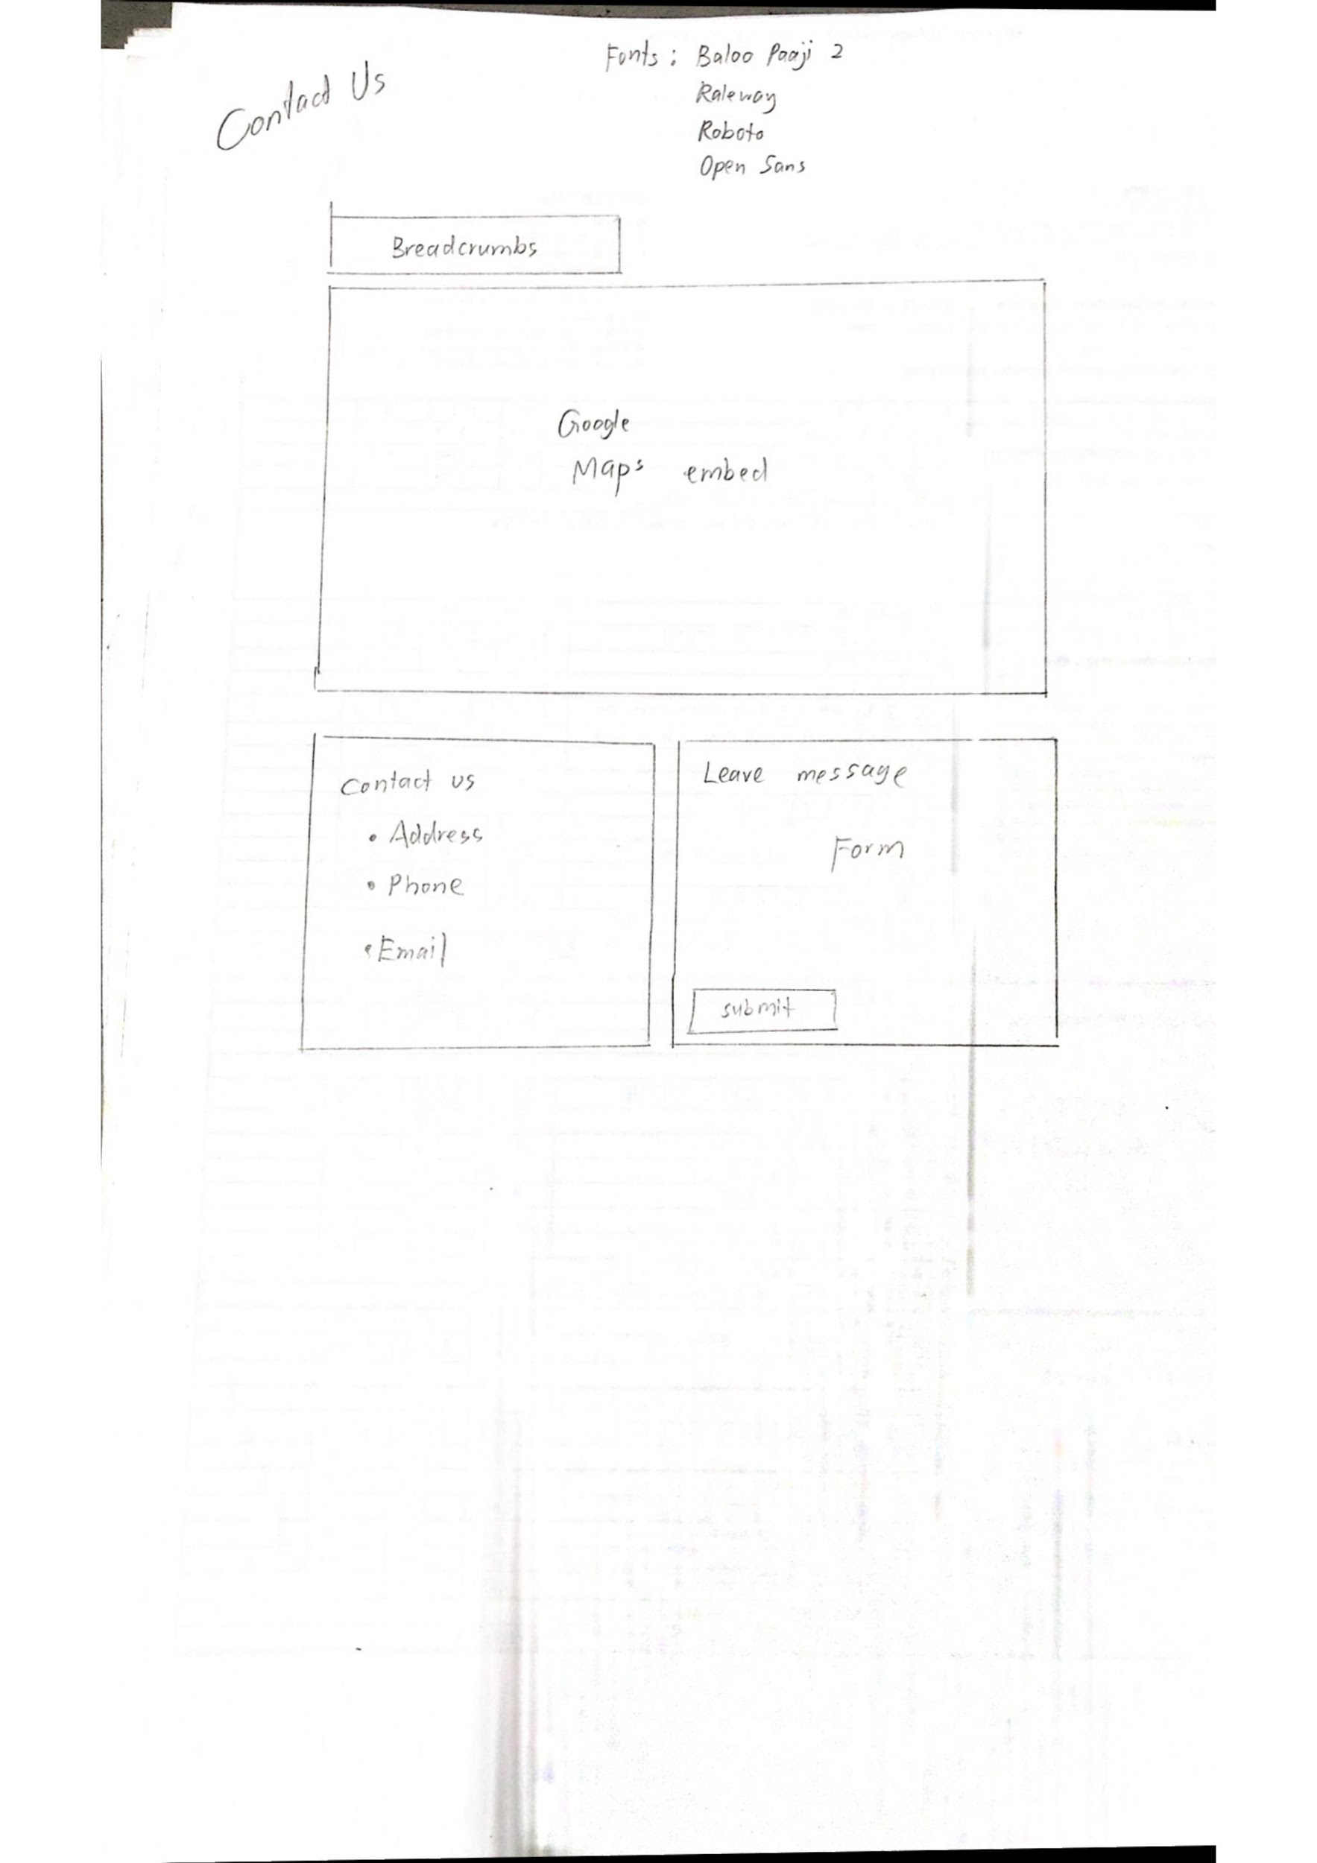

**Contact Us Page**

On the top, there’s breadcrumbs to previous pages.

Within the page, there’s a map that shows the location of the shop, details of the address, phone number and the email of the shop and a form to leave comments for the staff.

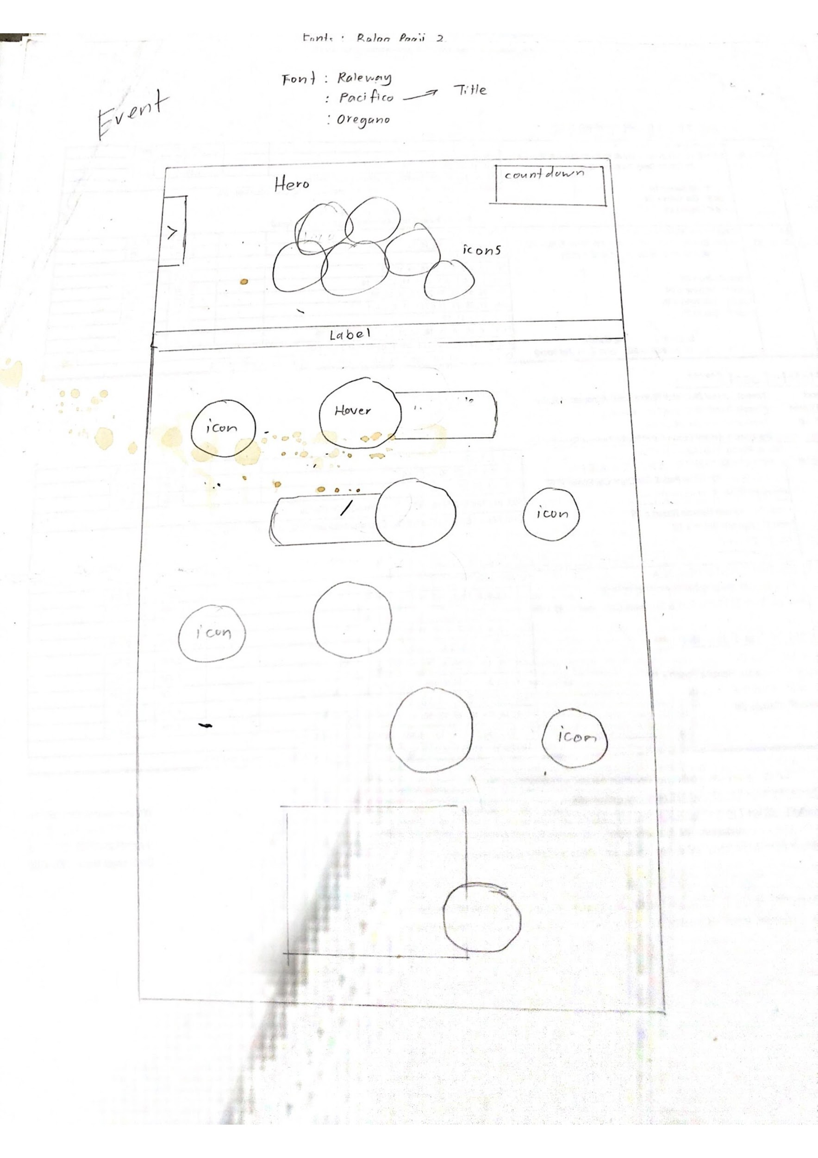

**Event page**

The page contains the winter event sale for certain shoes. It is an underwater pokemon themed event. In the hero section, there is a hover-able info box that shows the introduction of the event and a countdown timer for the event. The icons (Pokemons) within the hero section can be clicked and it’ll redirect you to its corresponding sale item. At the bottom of the hero section shows a bar that can be clicked and will redirect you to the first item.

For every item, you’ll have to hover-over the picture of the shoe to show the details of the items.

And for the last item, there’s two moving icons to signify the most anticipated item from the others.

**Main page for showing shoes**

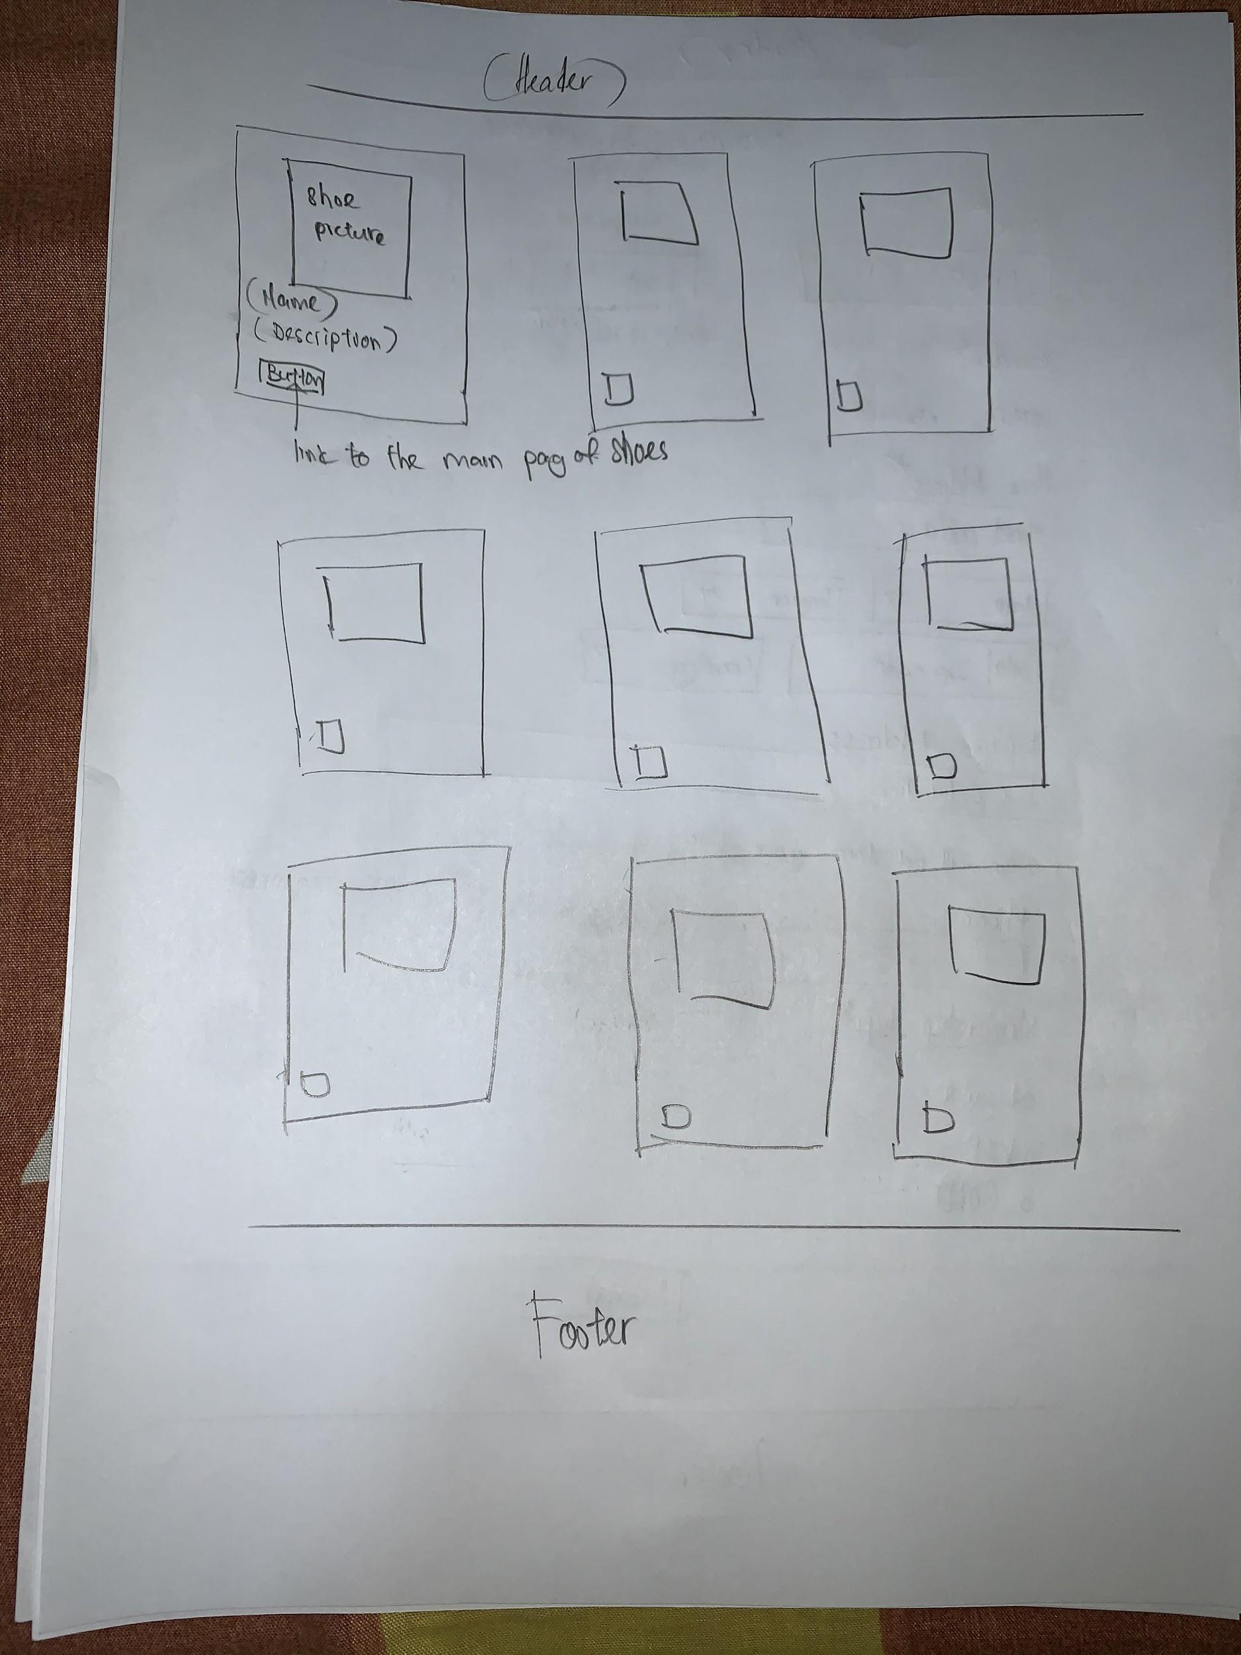

The main layout is black and white so that customers can focus more on the color of those beautiful shoes instead of the layout of our webpage. All of the shoes are linked with a button which redirects them to the main page of the shoes that have been selected, this can provide more interaction with the customers.

**Page for single shoes**

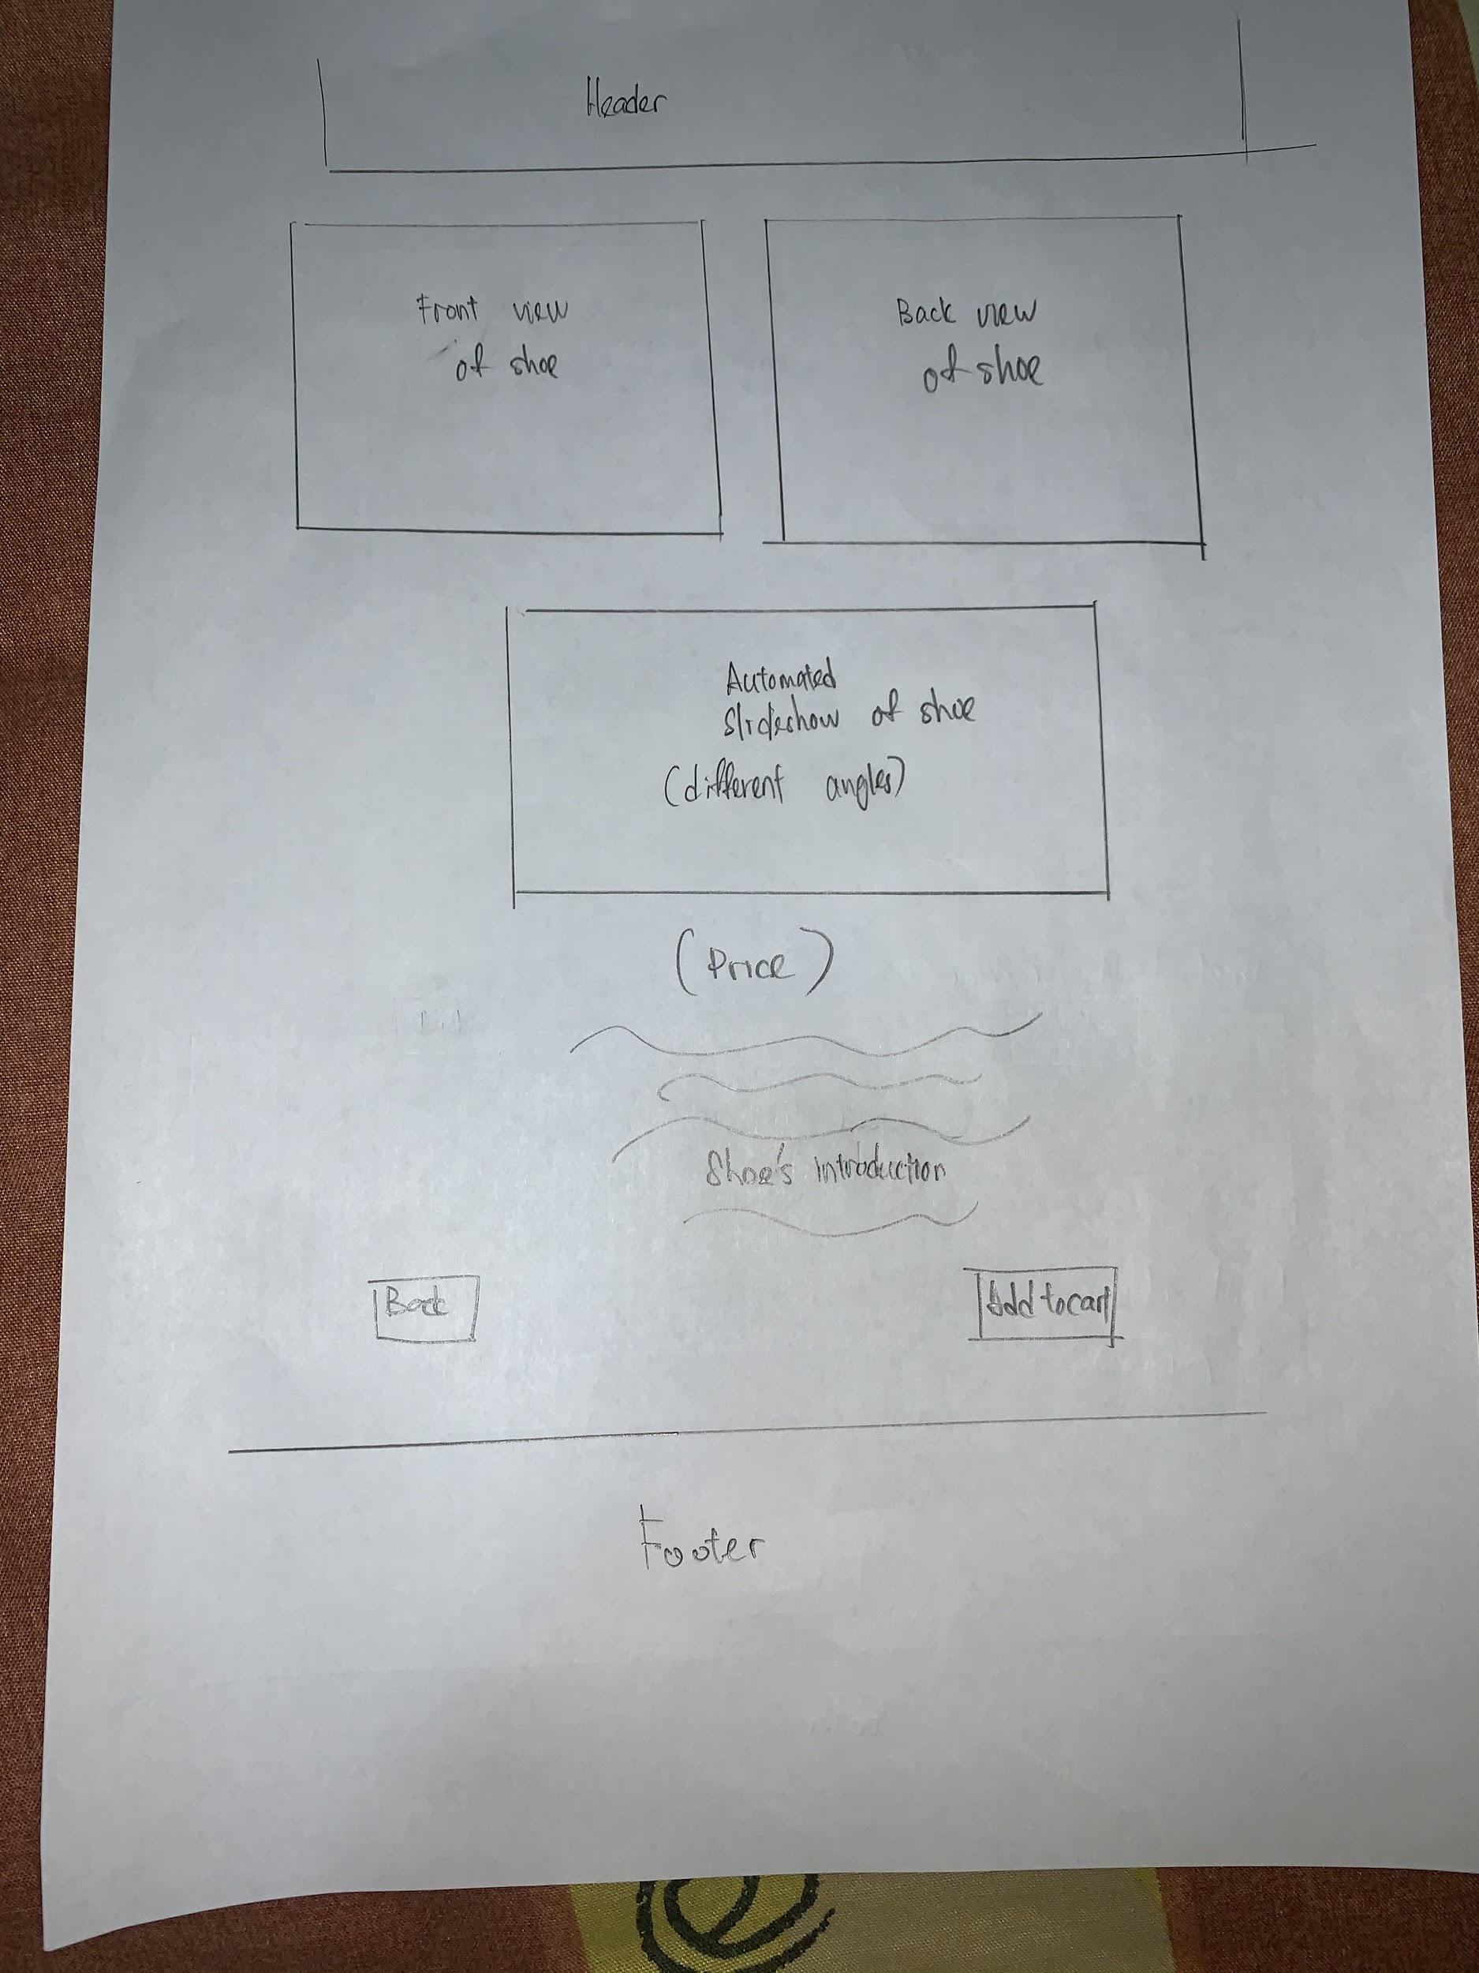

This page is mainly used to show customers the description of the shoes including the price of the shoes. There are also a few different pictures from different angles of the shoes to help customers understand the overall design from front to back of the shoes he/she is viewing. It also consists of buttons which will redirect customers back to the previous page. In addition to an add-to-cart button to add the product to the cart.

**Feedback form**

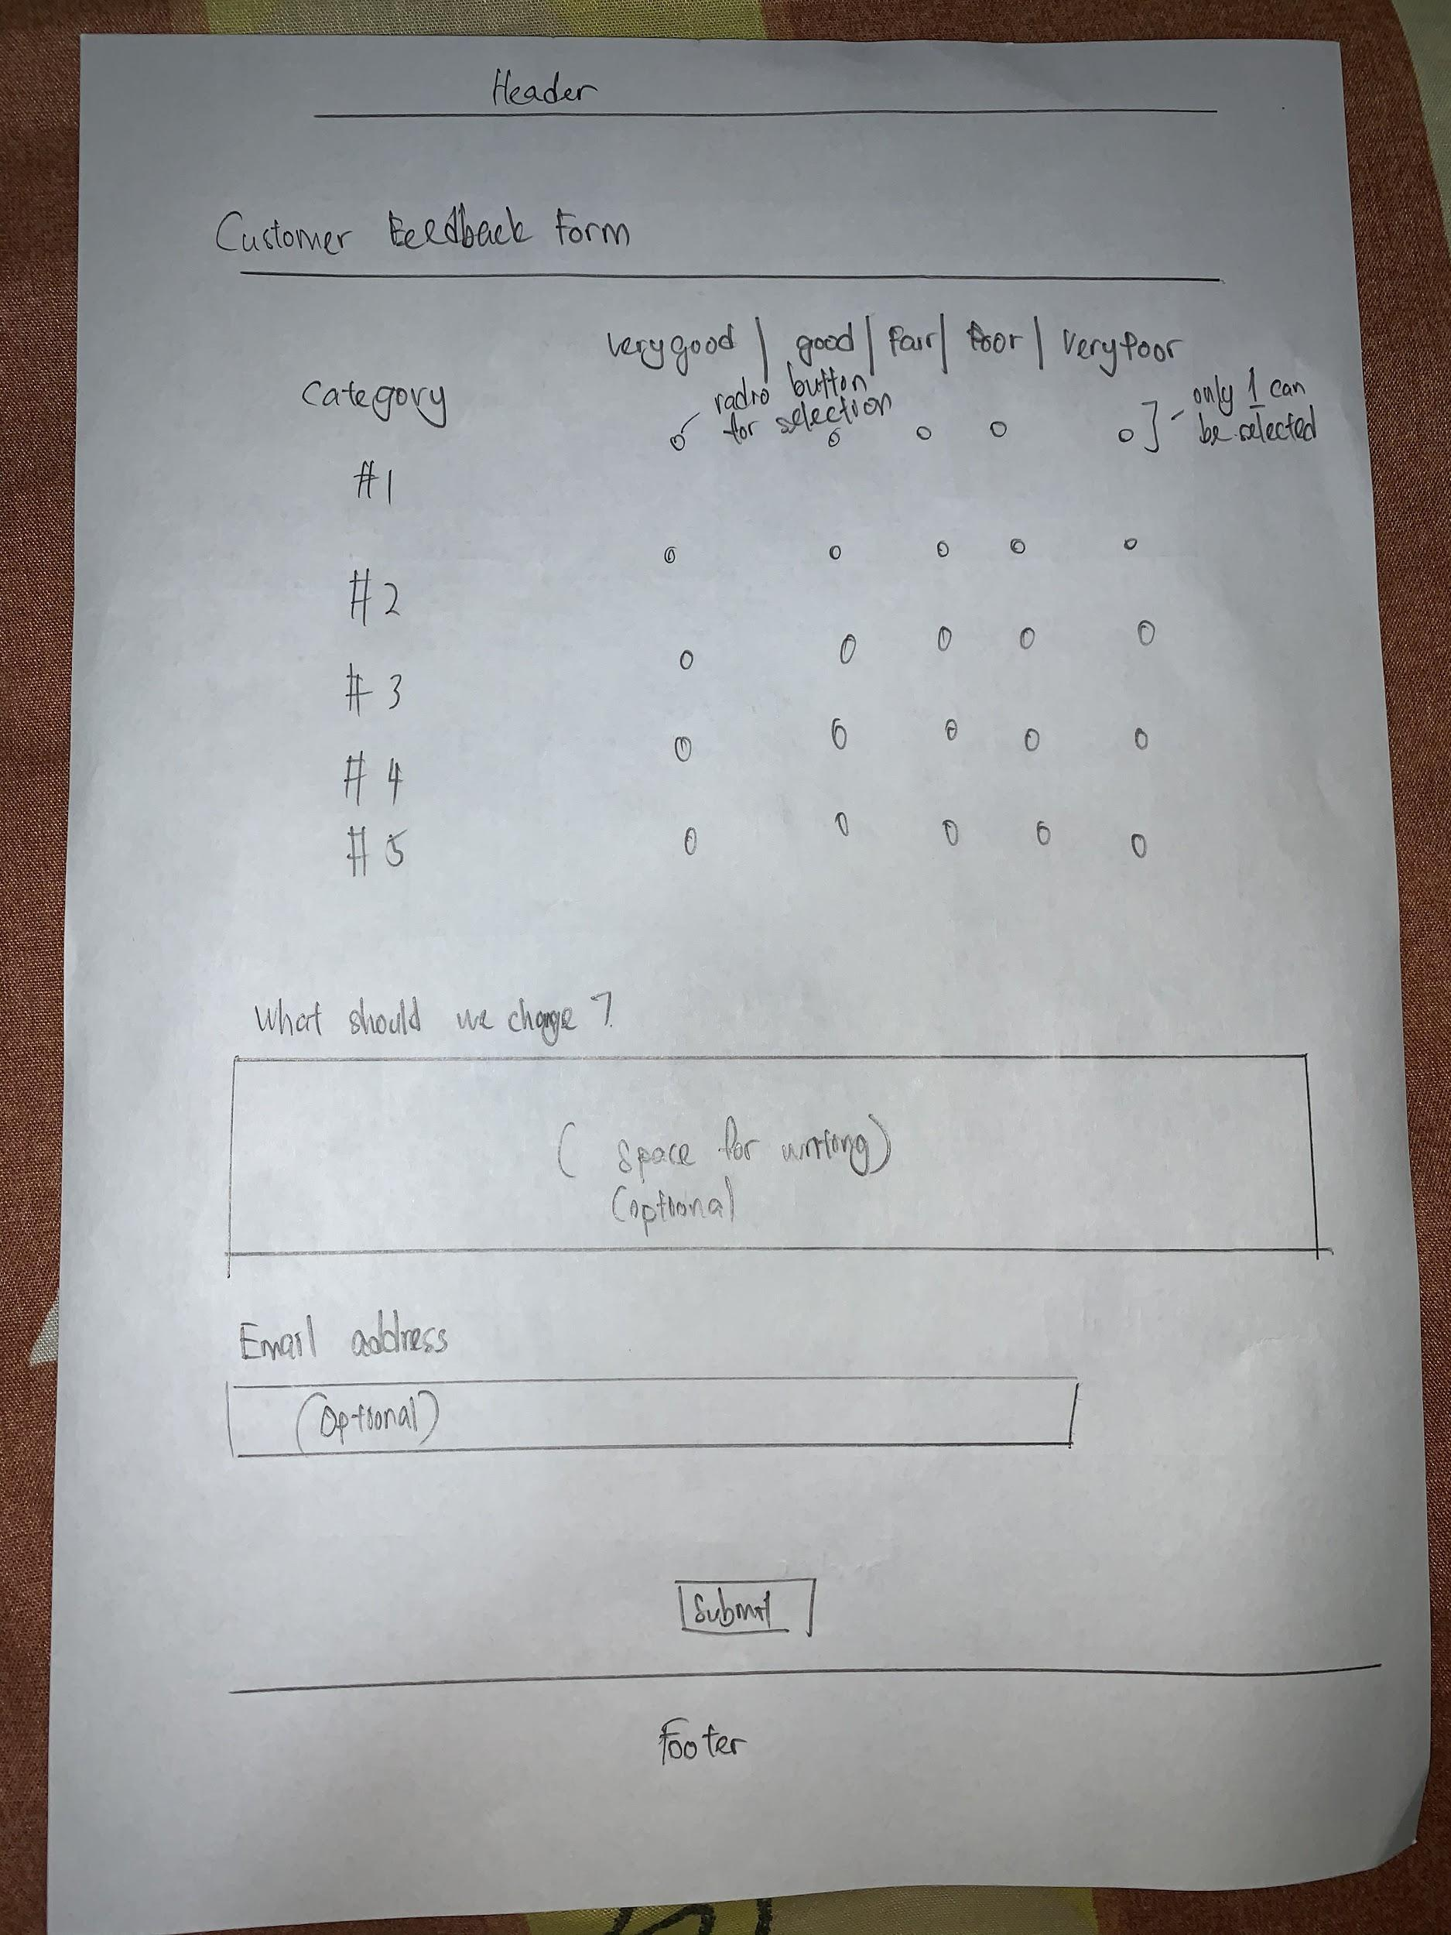

This page is mainly for customers to list down and rate the overall service of our shops and the quality of the products so we can make improvement .The feedback form submitted will be sent to our headquarter for viewing.

**Register form**

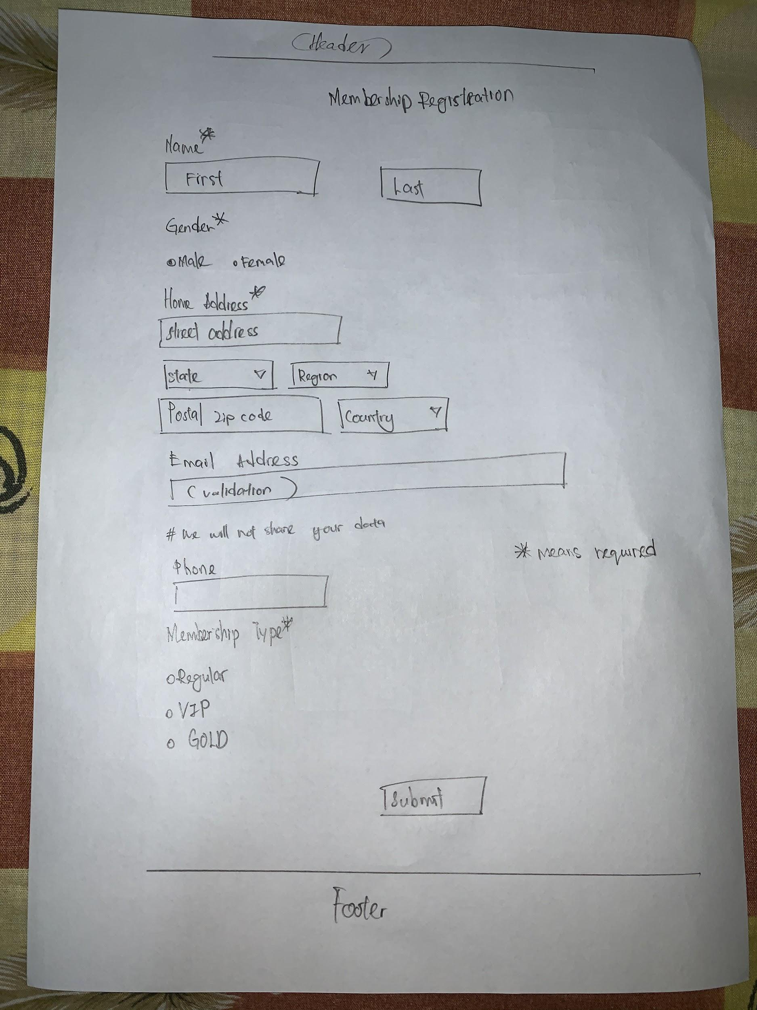

This is the form for customers to register as a member of our shop.There will be discounts given to the member of our shop .This form will be able to collect all the information of the customer that wish to register as a member.There will also be some validation and required spaces for them to fill in .After the submit button ,their information will be sent to our headquarter and their membership will be produced in a few days .All of the information will be sent to their respective email address .

**Shopping Cart**

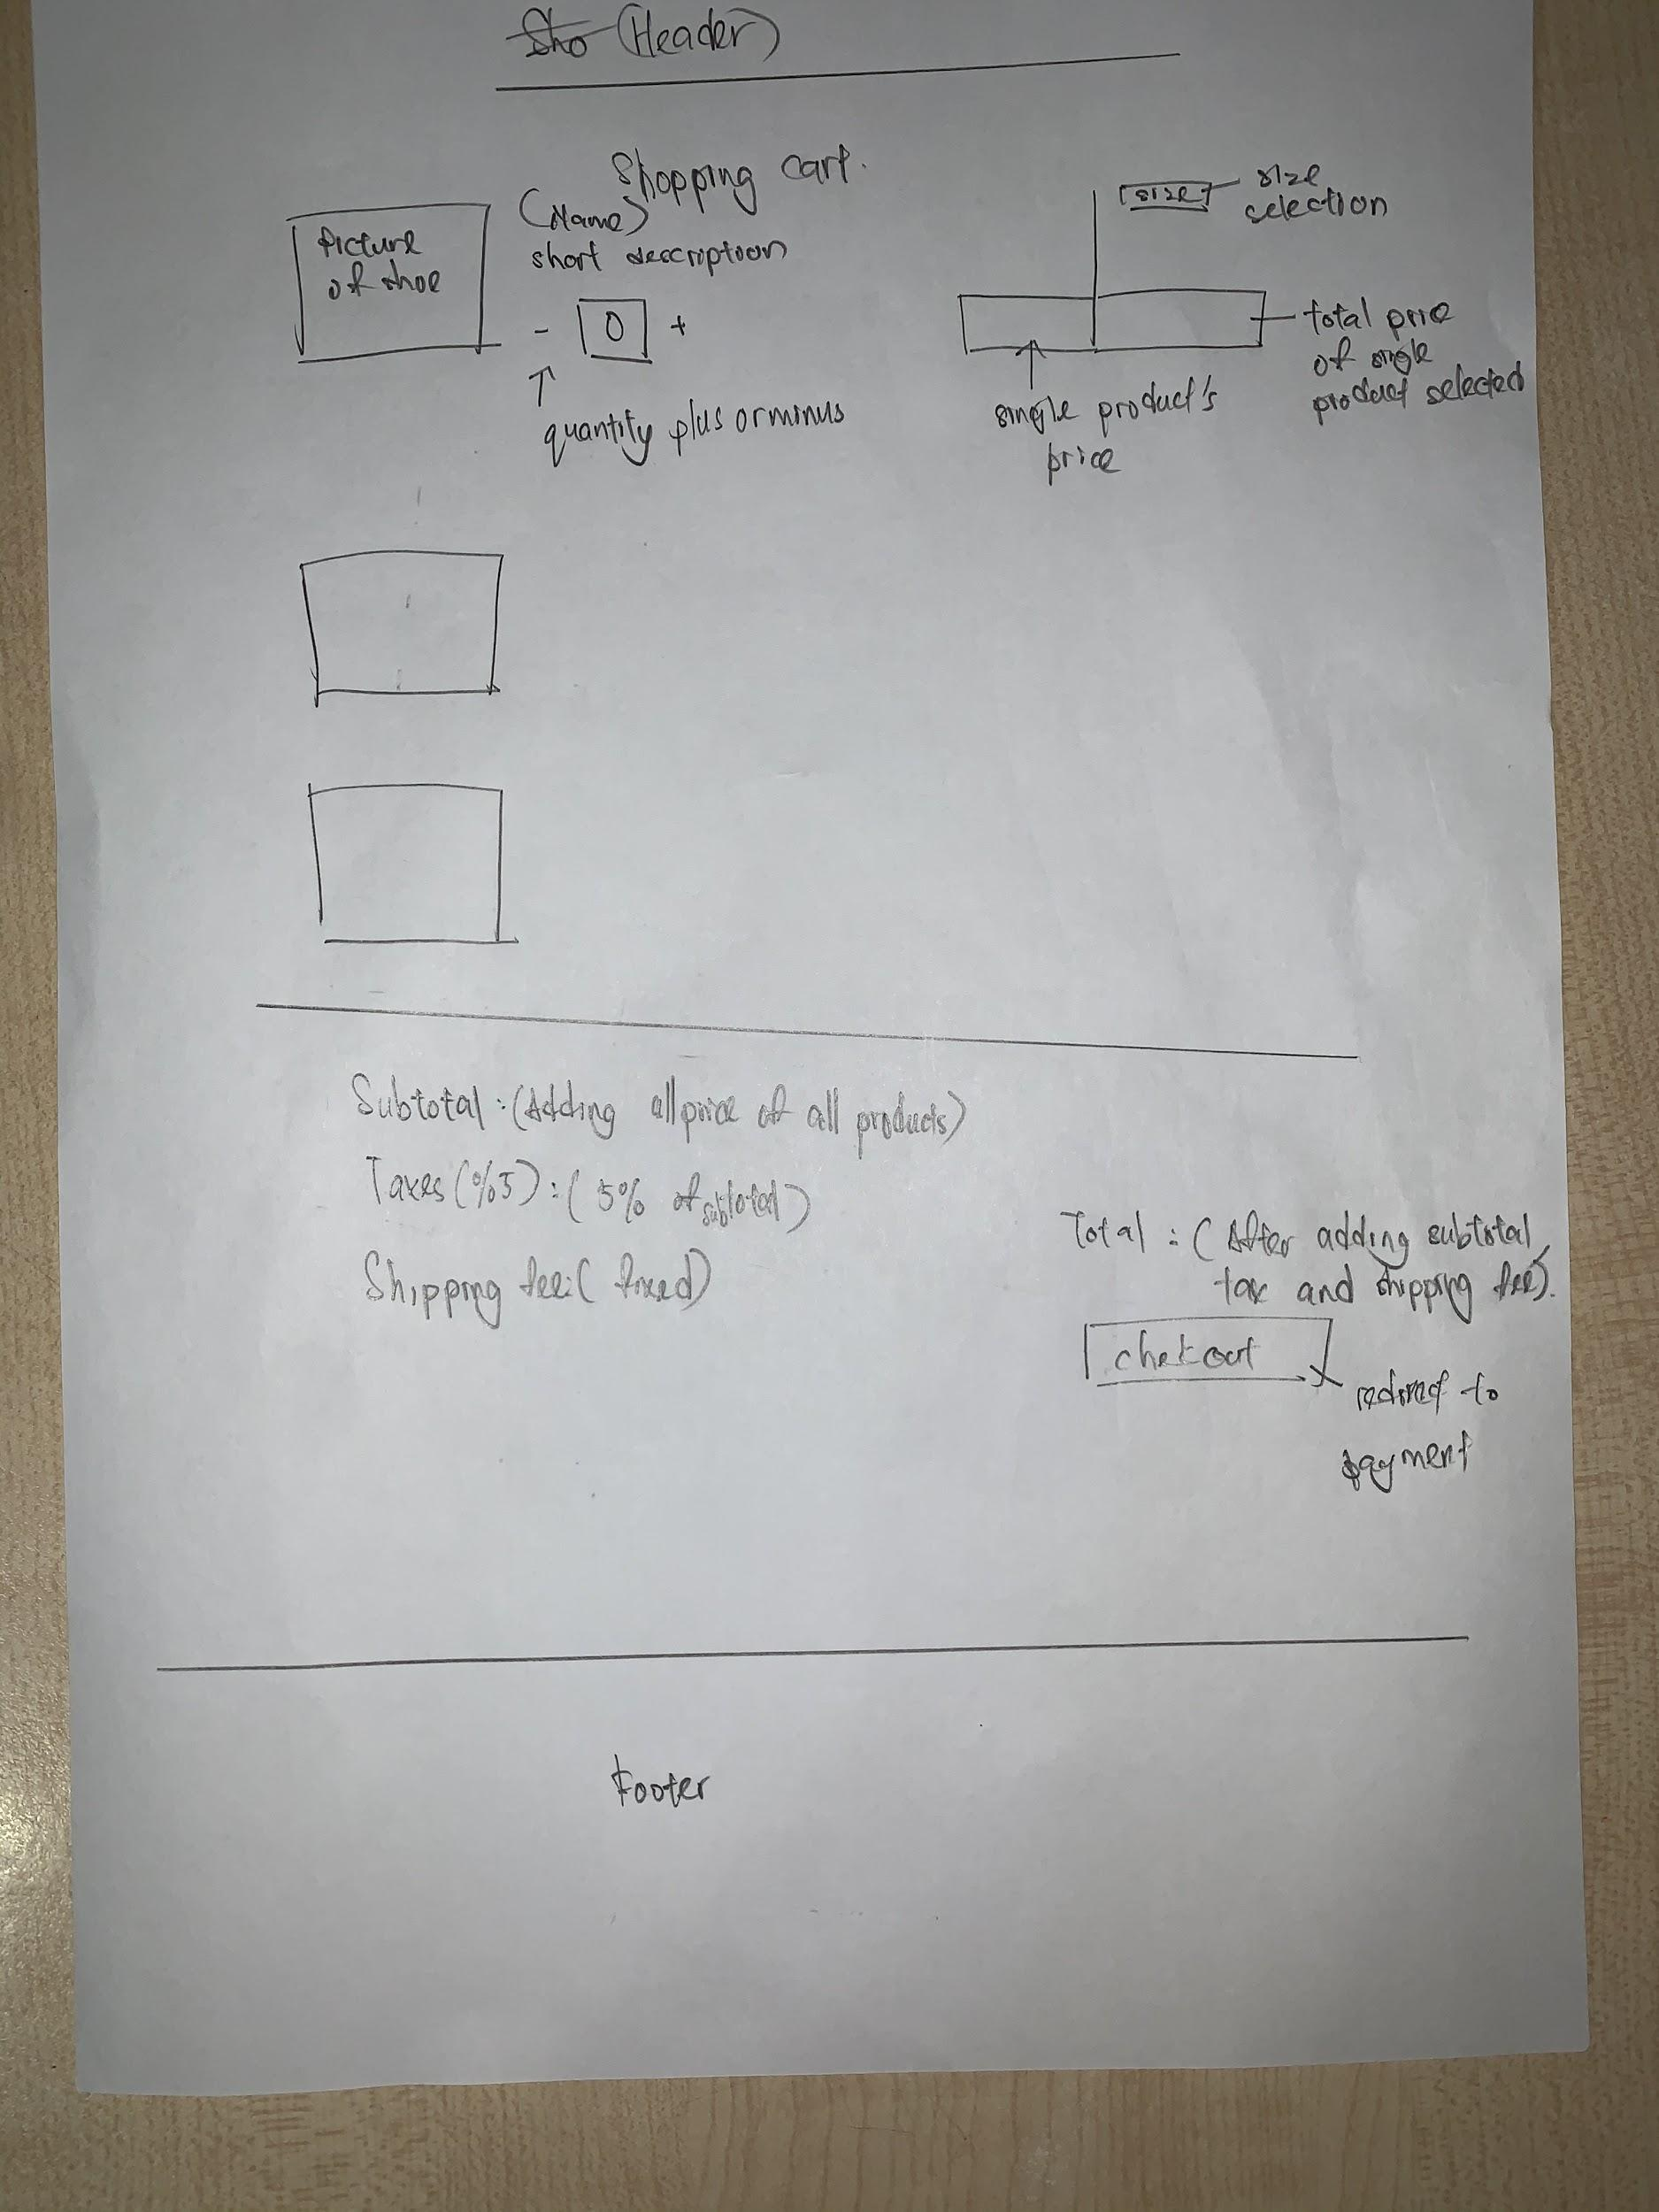

This is where customer select what they wanted to buy by pressing the + button and they can also select the size ,they can select multiple shoes at once ,the total price on the item selected is calculated ,the total price of all item selected is shown in the bottom part of the page ,it will also show the price of the taxes and the final price after adding everything including product’s price ,tax and delivery fee .The checkout button will redirect customer to do the payment

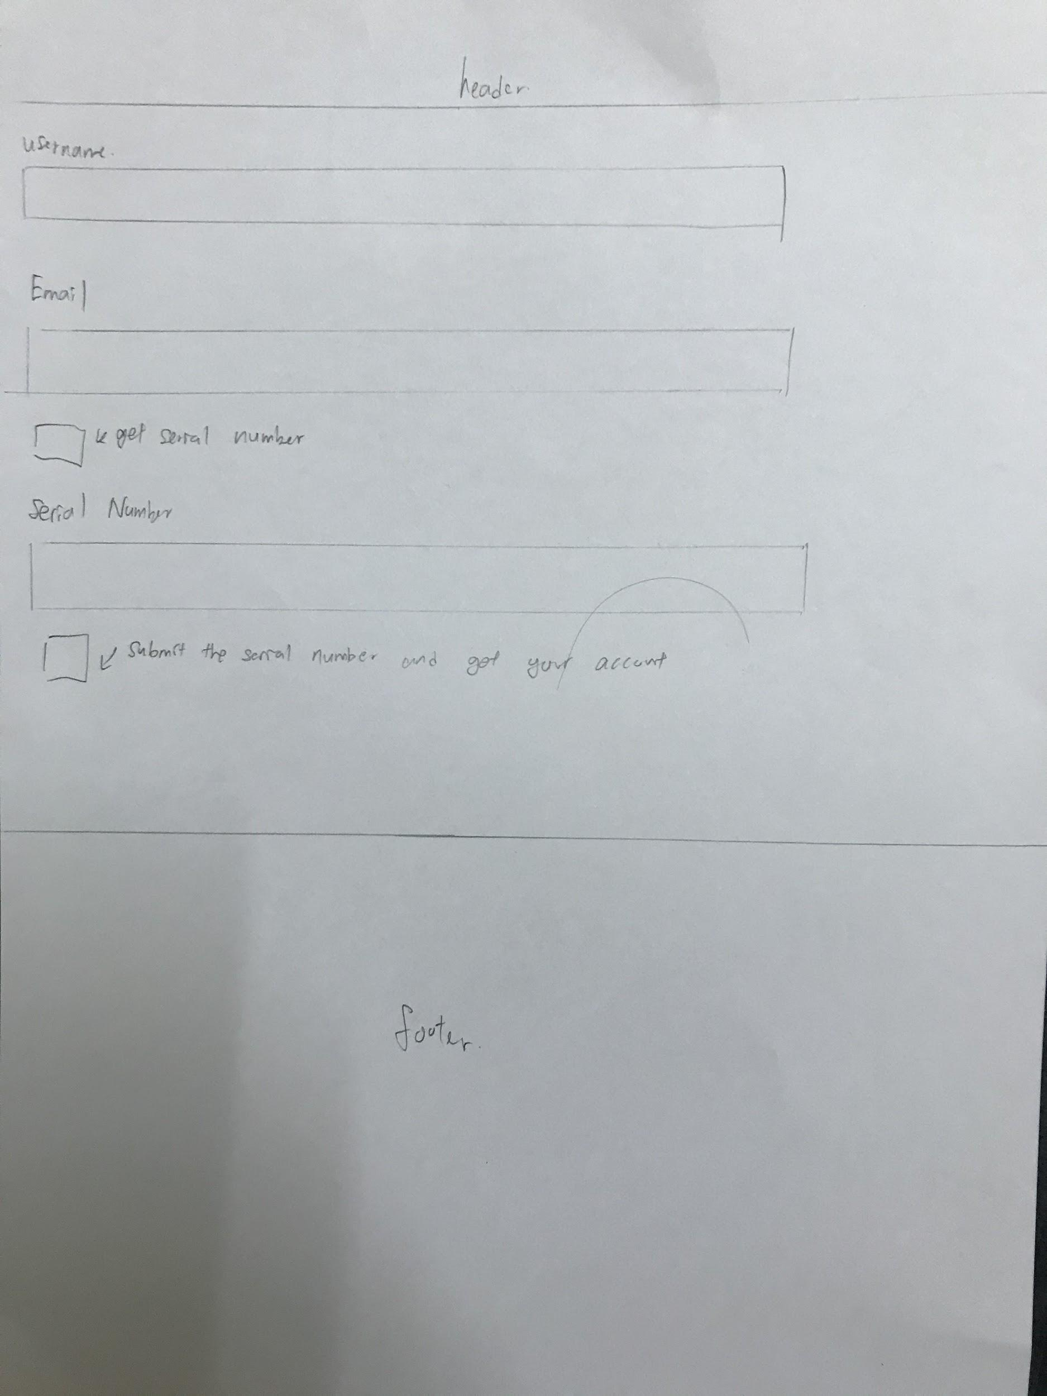

**Find back members’ account**

This page is for if a member forgot his password or username, the member can find it back in this page. Members should enter his name and email.And then he clicks and gets the serial number in his email.Then he enters the serial number and submit.The member can get back his ID.

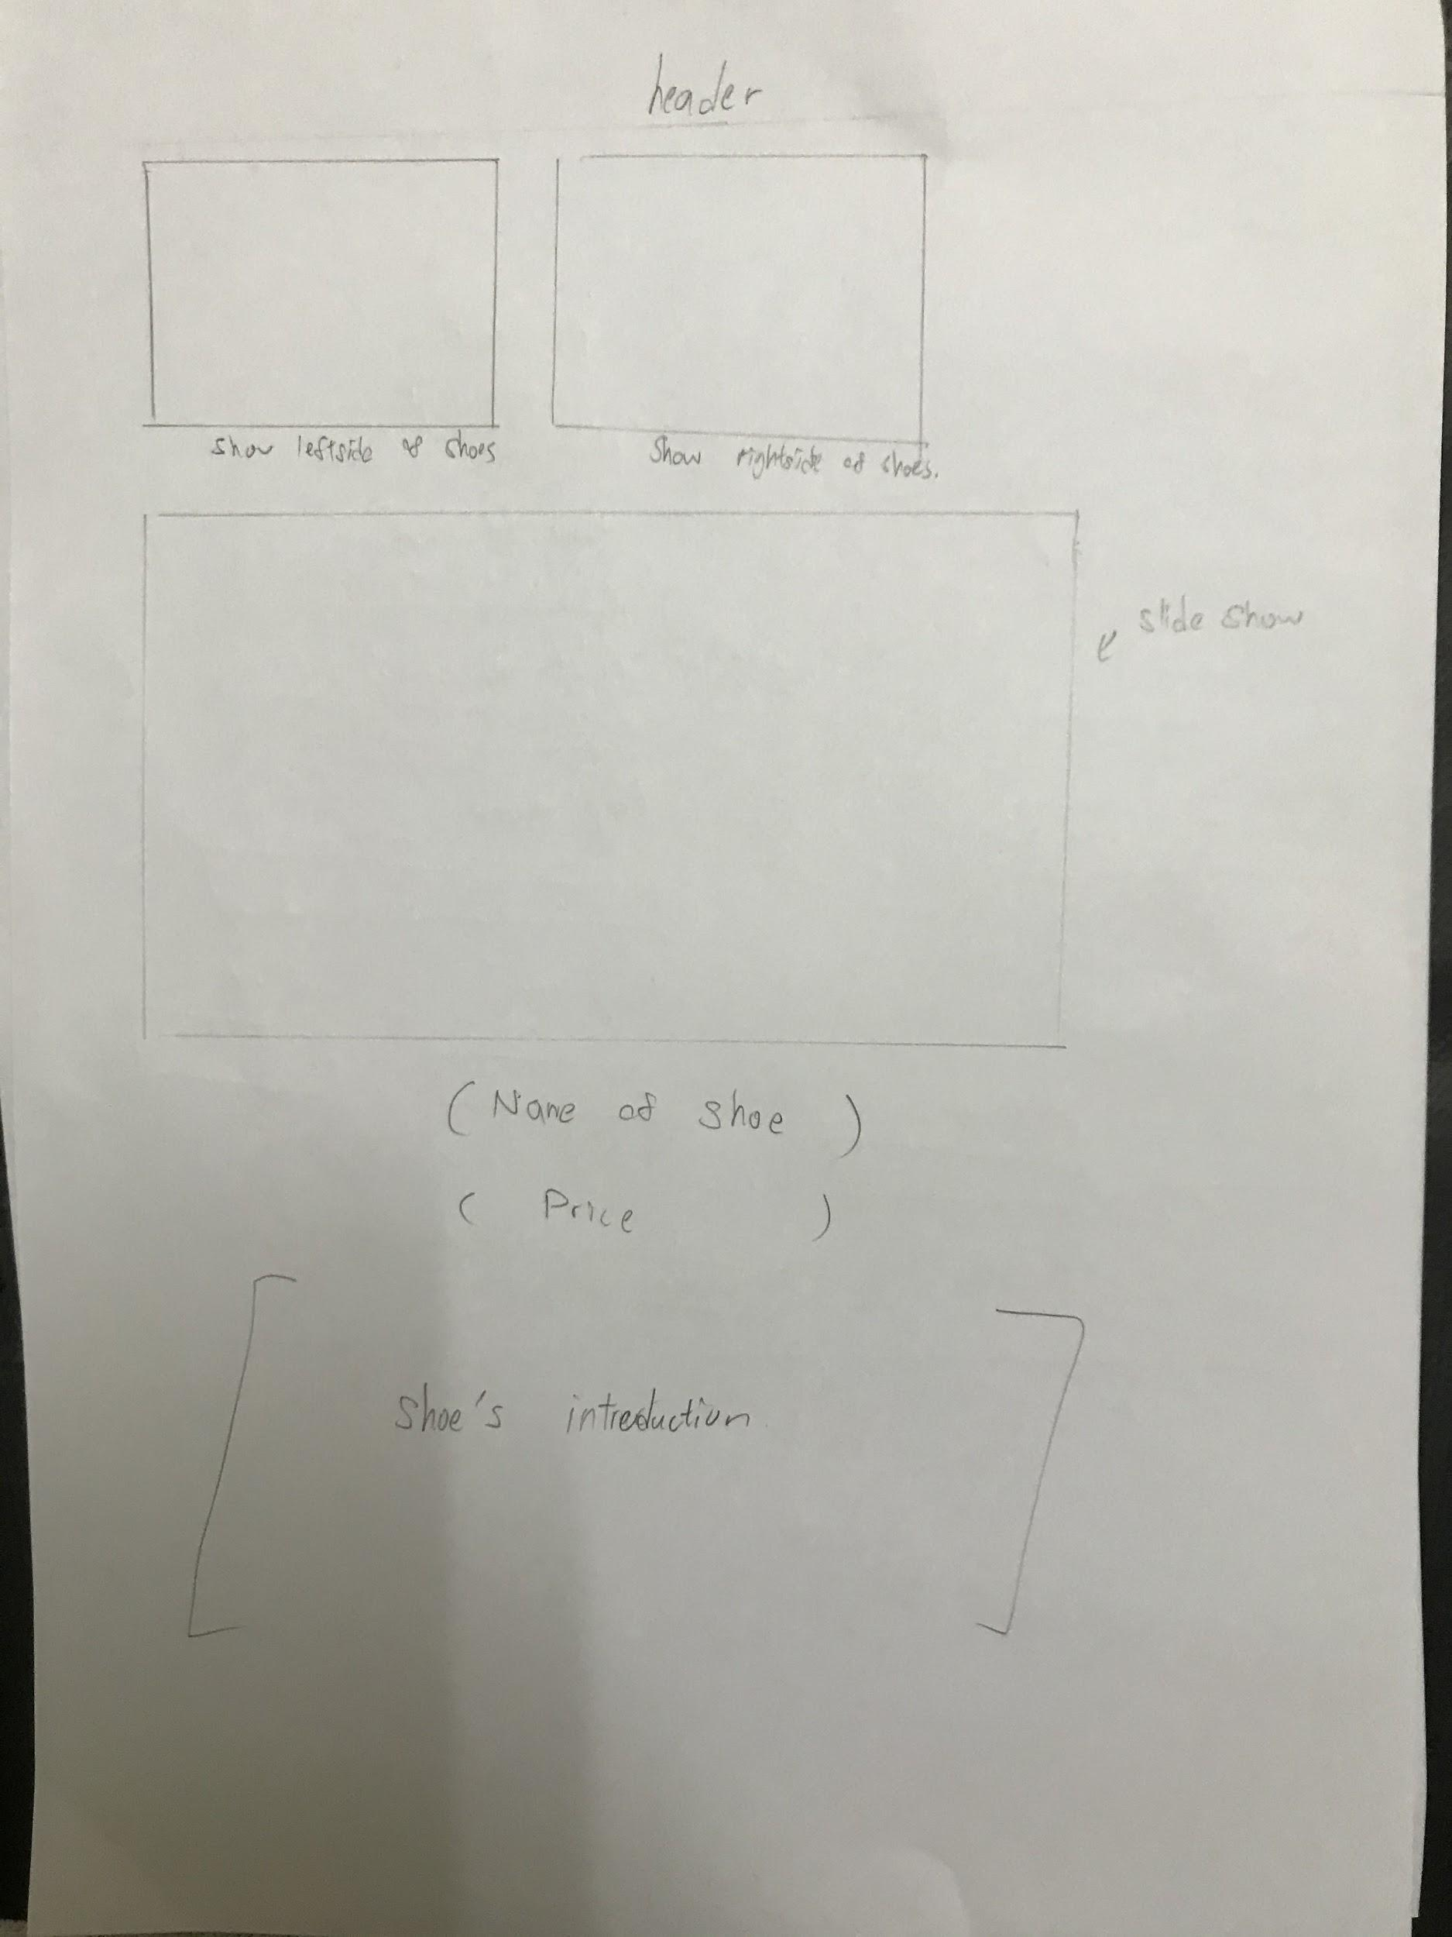

**Page for single shoes**

This page is primarily used to provide buyers with an overview of the product, including the price of the product. There are even a few various images from multiple perspectives of the shoes that help buyers appreciate the general style from the front and the back of the shoes they wear. This also consists of buttons that guide consumers back to the previous tab. In addition to the add-to-cart click, attach the drug to the basket.

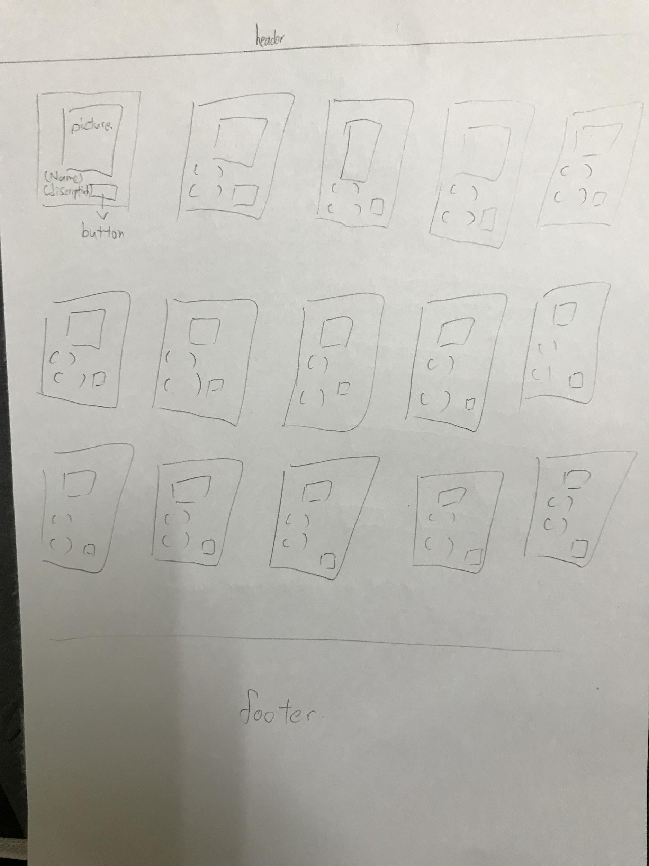

**Main page for showing shoes**

The key theme is black and white so that buyers can concentrate more on the colour of these exquisite shoes than on the style of our website. Both shoes are connected to a button that redirects them to the main page of the shoes that have been picked, and will have further contact with the customers.

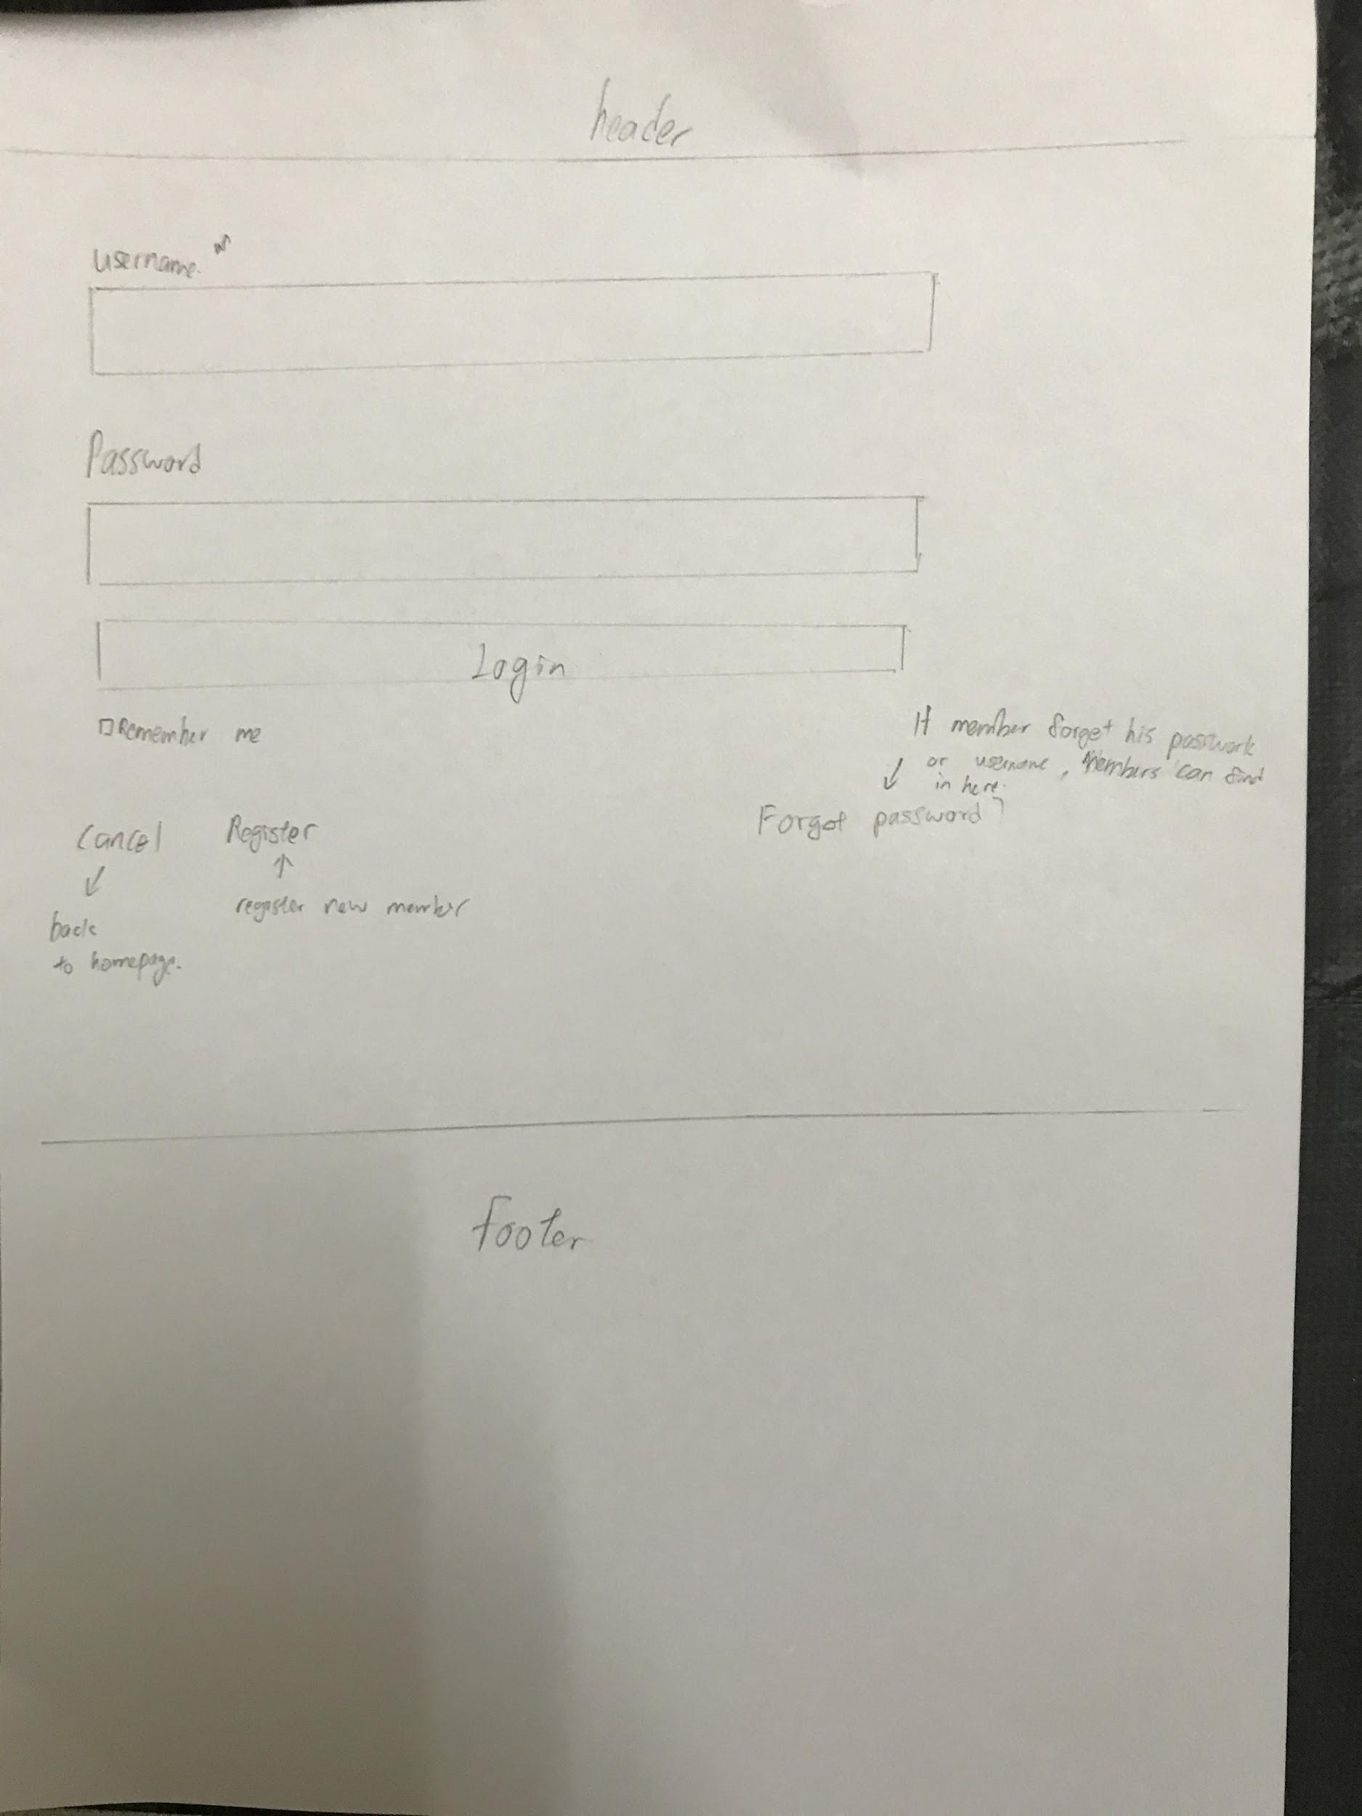

**Login**

This is the page that allows customers to sign in after they already become our company member.First the member needs a username and password of the account. If members need to register a new account. He can click the register to get his new account. You also can cancel login and back to homepage.If the member forgets his password or username, he can click the forget password to get back his account.

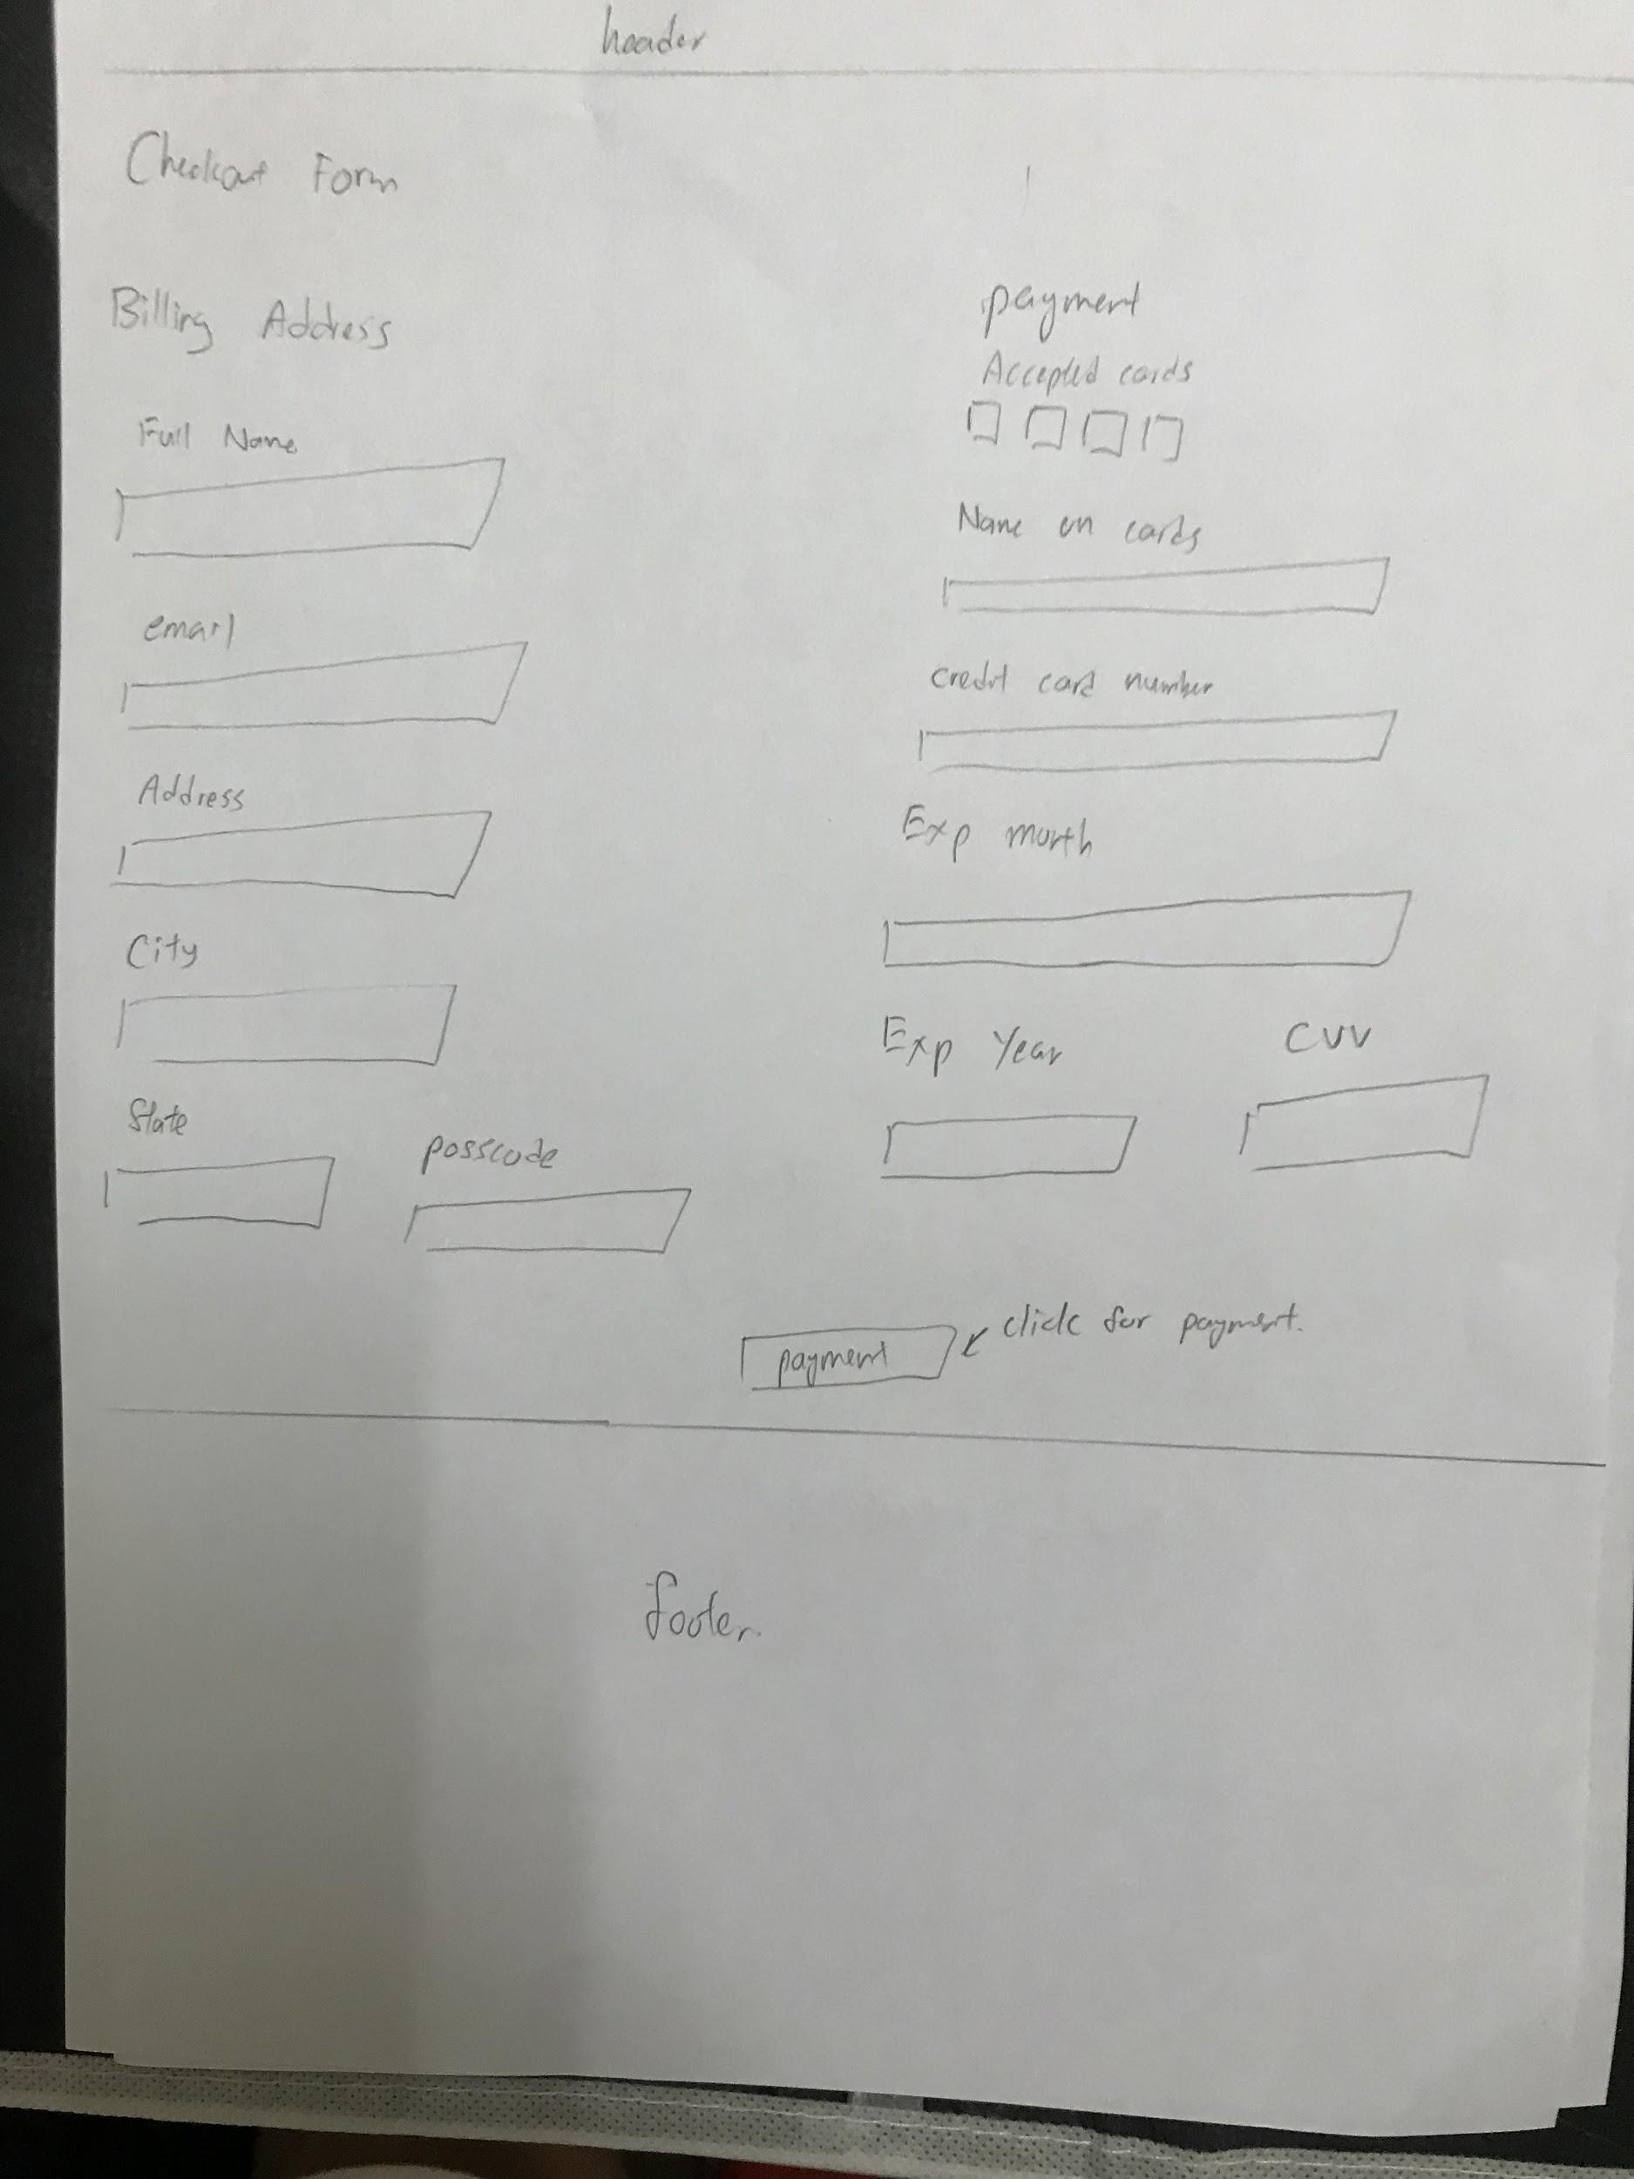

**Checkout**

This page lets the customer to checkout their order. Customers can choose the payment method and take details of the card such as name on credit card, credit card number, expired month and year and cvv. And then, customers need to fill up their details such as name, address and email. This is because the company knows which customers buy and can deliver items to their house.

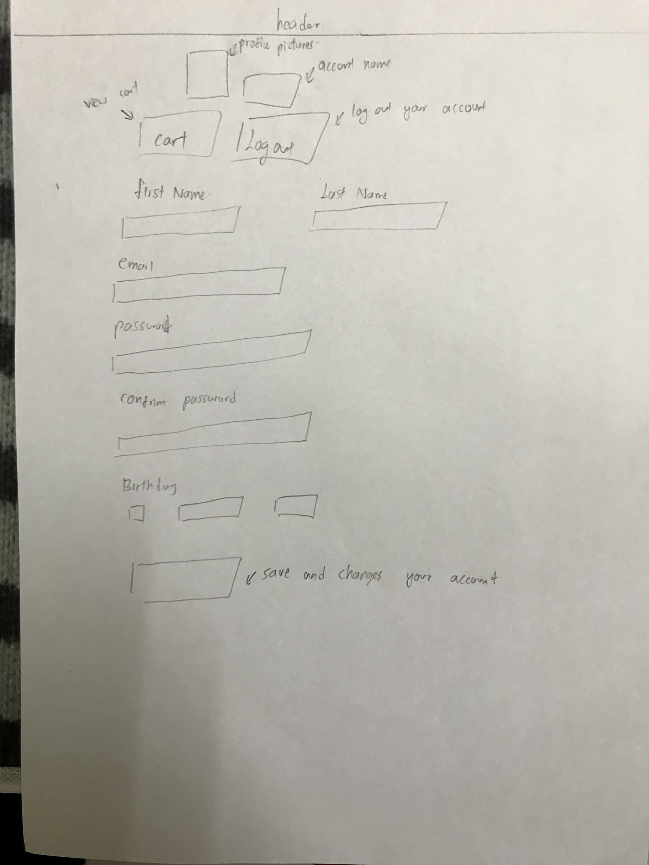

**Profile**

This page lets the member double check his account and see any details needed to edit his profile such as name, email, password and birthday. .And the member can view what item in his cart and he can log out his account.

**Homepage**

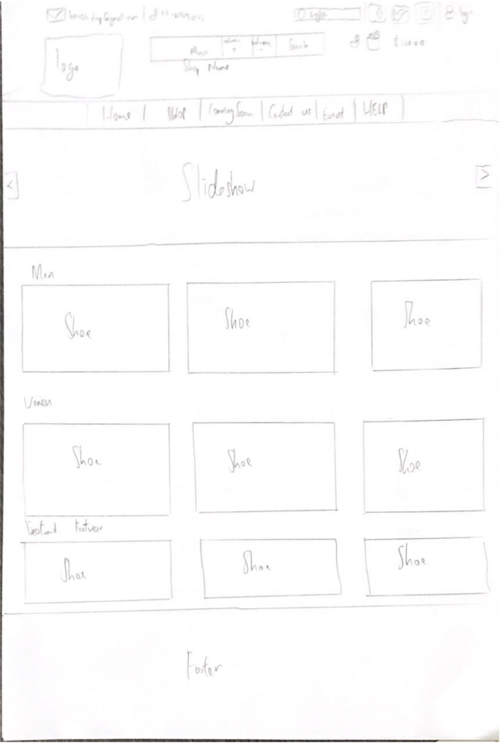

This page is showing the main page of the shop. The customers are allowed to see what shoe that most people like to buy. The customer also can get to know some of the shoes of our shop that display at the home page.

**About Us**

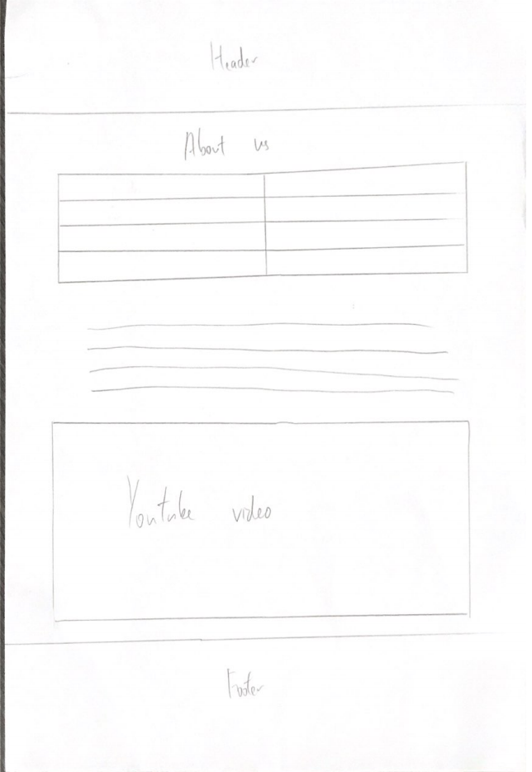

This page let the customer know about our shop's history. They also can know the purpose that we create this shop. In this page, we also let the shoe lovers know the process of making shoes.

**Help**

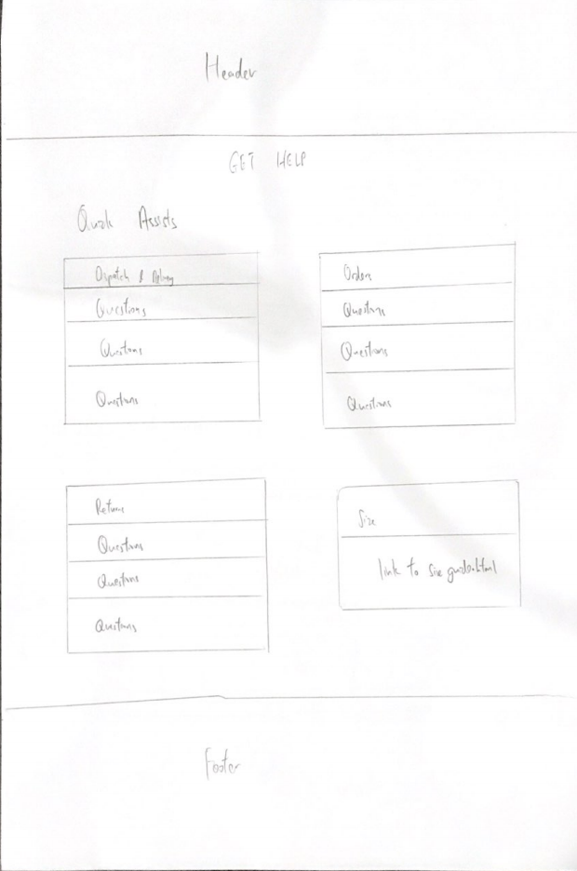

This page shows some common questions that most of the customers will ask. Customers can get to know the answer that they will ask in there.

**Size Guide**

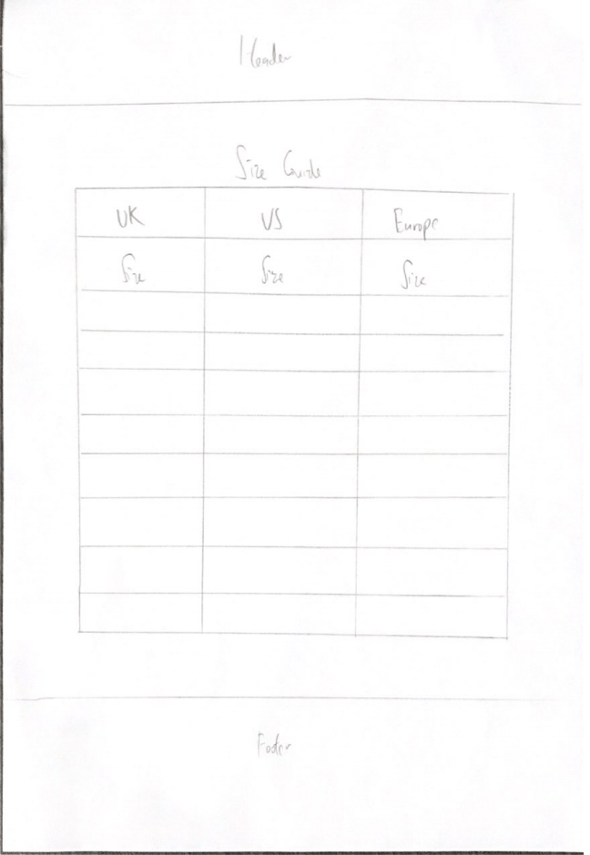

Customers that do not know his/her shoe size can search his shoe size on this page.

**References**

* Anon, Available at: https://codepen.io/matchboxhero/pen/JrLJeb?editors=1100 [Accessed April 26, 2020].
* Anon, 2019. 10 Free Shopping Cart UIs in CSS and JavaScript. *Speckyboy Design Magazine*. Available at: https://speckyboy.com/free-shopping-cart-css-javascript/ [Accessed April 26, 2020].
* Dronca, R., 2020. How to Create a Shopping Cart UI using CSS & JavaScript. *Designmodo*. Available at: https://designmodo.com/shopping-cart-ui/ [Accessed April 19, 2020].
* Anon, How TO - Custom Checkbox. *How To Create a Custom Checkbox and Radio Buttons*. Available at: https://www.w3schools.com/howto/howto_css_custom_checkbox.asp [Accessed April 5, 2020].
* Anon, Nike. Just Do It. Nike.com. *Nike.com*. Available at: https://www.nike.com/my/ [Accessed March 29, 2020].
* Otto, M. & Thornton, J., Cards. *· Bootstrap*. Available at: https://getbootstrap.com/docs/4.4/components/card/ [Accessed May 1, 2020].
* Anon, Sneakers, Streetwear, Trading Cards, Handbags, Watches. *StockX*. Available at: https://stockx.com/ [Accessed April 9, 2020].
* Colorlib. 2020. *800+ Free Website Templates | HTML & Bootstrap 2020 - Colorlib*. Available at: <https://colorlib.com/wp/templates/> [Accessed 20 April 2020].
* “How To Start A Blog From Scratch Using WordPress - Colorlib.” Colorlib.Com, colorlib.com/[Accessed 20 April, 2020].

**Appendix**

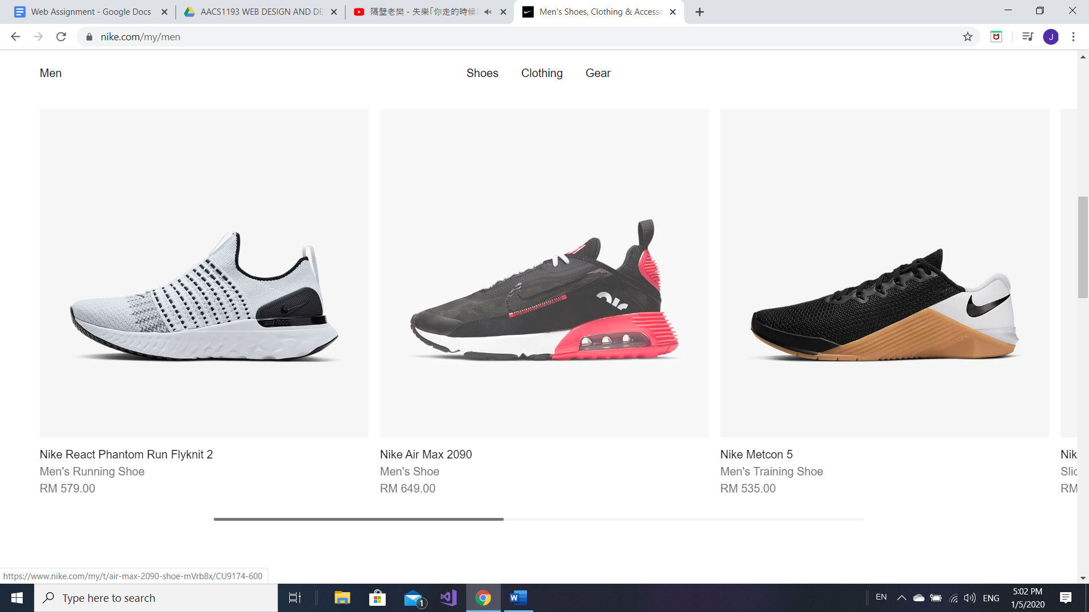

Showcase of shoes and names(<https://www.nike.com/my/>)

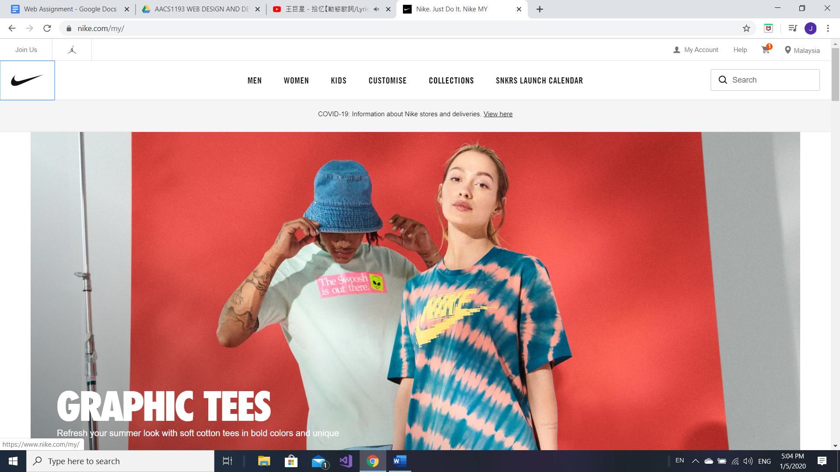

Homepage and header (<https://www.nike.com/my/>)

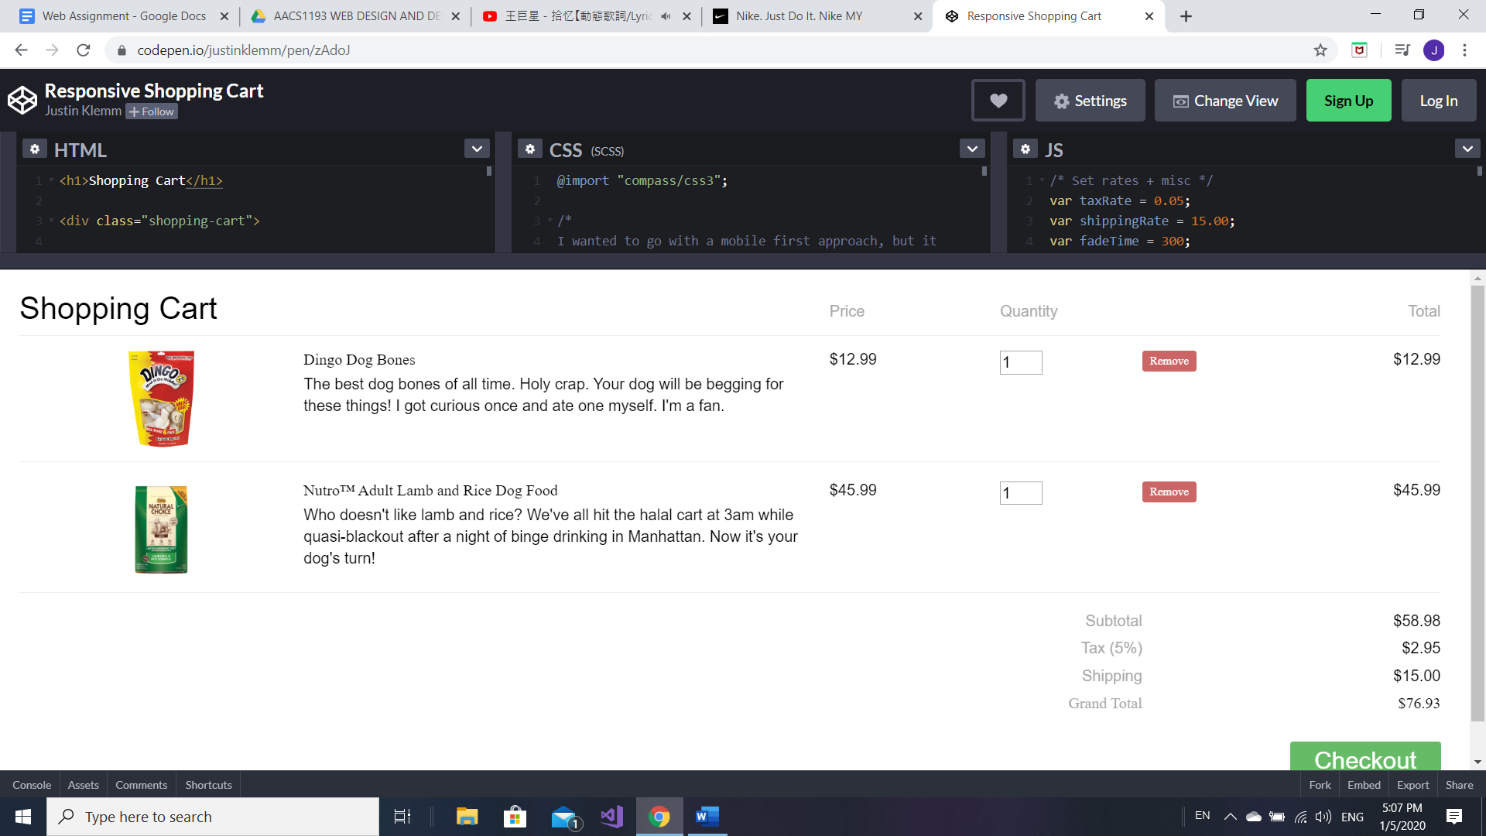

Shopping cart (<https://codepen.io/justinklemm/pen/zAdoJ>**)**

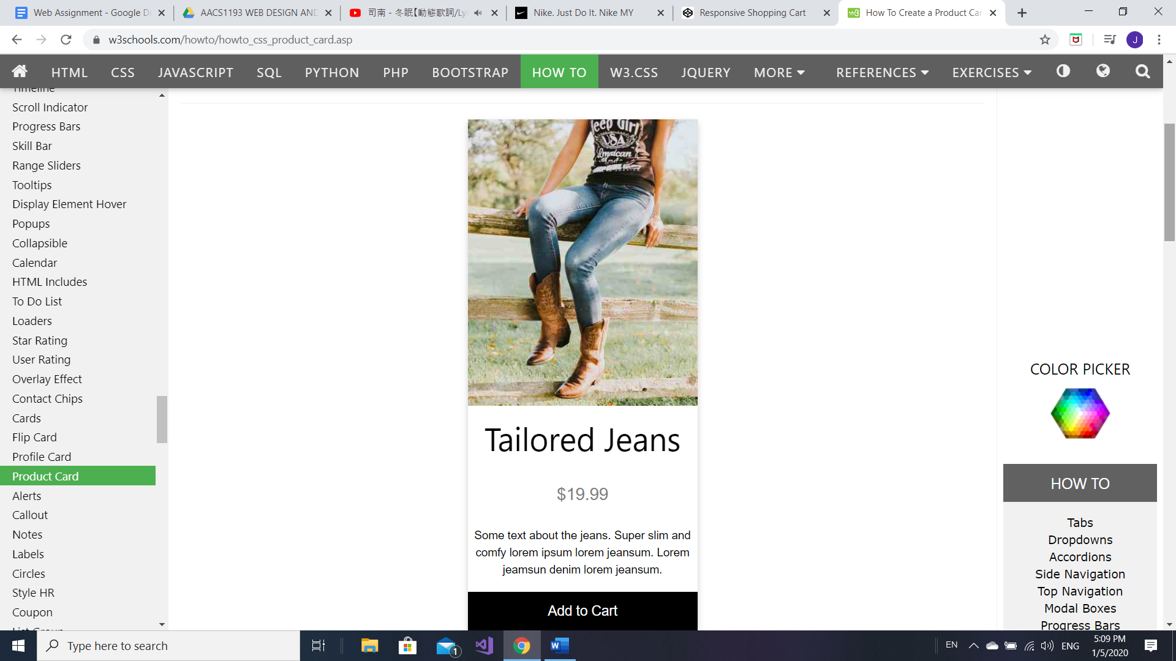

Product viewing (<https://www.w3schools.com/howto/howto_css_product_card.asp>)

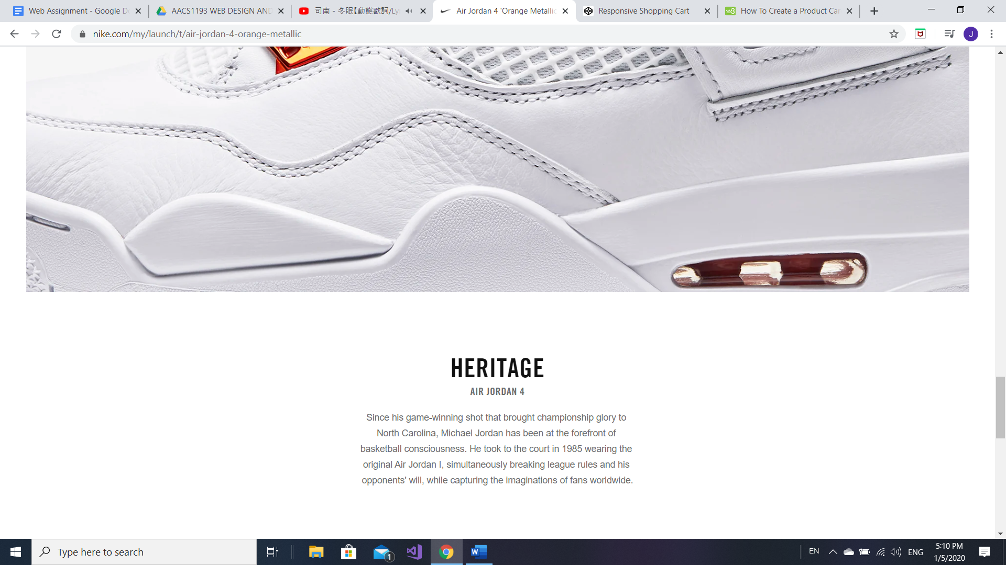

Viewing single product(<https://www.nike.com/my/launch/t/air-jordan-4-orange-metallic>)



Snow effect (<https://codepen.io/matchboxhero/pen/JrLJeb?editors=1100>)